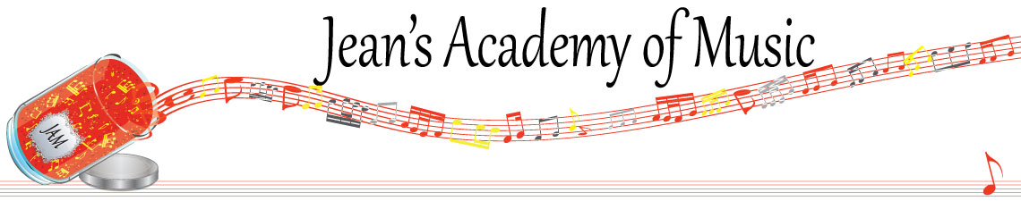

September 2025 “JAM” NEWSLETTER ALBERTA

**IMPORTANT DATES TO MAKE NOTE OF:**

September 10 1st lesson day of the new music year

____________________________________________________________________________

**Tuition:**

* **Tuition for lessons is due ON THE 1ST OF EACH MONTH IN ADVANCE unless other arrangements are made.**
* **NOTE: MASTERCARD, VISA, AND DEBIT ARE STILL AVAILABLE BUT WILL HAVE the percentage added as per the amount I’m charged with Square.**
* **When setting up eTransfer, please make it repeating for the 1st of each month up to and including June. The tuition is divided up over the 10 months equally for ease of budgeting and simplicity.** [**\*\*\*soultonesstudio@gmail.com**](mailto:***soultonesstudio@gmail.com)
* **Please look after the tuition without requiring monthly invoices.**
* **REMEMBER: a late payment fee has been introduced FOR PAYMENTS NOT RECEIVED BY the 15th of the month. This will be a flat fee of $40.00.**

ALL FORMS AND PIECES OF INFORMATION ARE ON THE WEBSITE: [www.jeanacademy.com](http://www.jeanacademy.com)

* JAM calendar
* Policy
* Newsletters
* Registration forms

________________________________________________________________________

**“Children can learn music as naturally as they absorb the nuances of their native tongues!”**