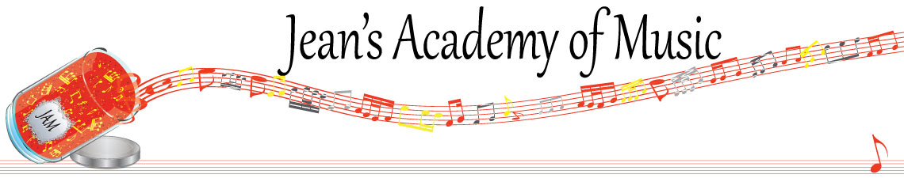

October 2025 “JAM” NEWSLETTER

**IMPORTANT DATES TO MAKE NOTE OF:**

October 13 Thanksgiving Day NO LESSONS

November 4 RCM exam application deadline

____________________________________________________________________________

**Tuition:**

* **Tuition for lessons is due ON THE 1ST OF EACH MONTH IN ADVANCE unless other arrangements are made.**
* **NOTE: MASTERCARD, VISA, AND DEBIT ARE STILL AVAILABLE BUT WILL HAVE the percentage added as per the amount I’m charged with Square.**
* **When setting up eTransfer, please make it repeating for the 1st of each month up to and including June. The tuition is divided up over the 10 months equally for ease of budgeting and simplicity.**
* **Please look after the tuition without requiring monthly invoices.**
* **REMEMBER: a late payment fee has been introduced FOR PAYMENTS NOT RECEIVED BY the 15th of the month. This will be a flat fee of $40.00.**

**NOTE: IN STUDIO/REMOTE LESSONS:**

* **Masks will be mandatory for in studio lessons in the Trafalgar Studio from October 14th onward.**
* **Sanitizer will continue to be available at the door upon entry and exit.**
* **The piano will be cleaned between families.**
* **If your child or anyone in your home is not well, please let me know and we’ll make arrangements for a remote lesson if necessary.**
* **Make ups are offered for lessons missed due to being sick but please provide as much notice as possible. Just missing is a forfeit and not eligible for a makeup.**
* **Do not send coughing and or feverish children to lessons please to either location.**
* **If the student is well enough to do a remote lesson in place of in person, we’re happy to accommodate that!**

ALL FORMS AND PIECES OF INFORMATION ARE ON THE WEBSITE: [www.jeanacademy.com](http://www.jeanacademy.com)

**Congratulations to Marya (21.3) and Rachel (24) the students of the month for September! Great work!! Honorable mention to Mahi (19.75) and Helena (21.3).**

**Develop great practice habits to see your name here!**

**________________________________________________________________________**

We are introducing a new system in the studio this year. Each student will receive a mark out of 10 each lesson. Marks will be determined through a point system that will be discussed at the group classes. They will receive a handout for their binders/duotangs. Students will have the opportunity to earn bonus marks as well. We will be promoting much memorizing this year and as always, rhythm….counting and fingering will be focused on. For returning students and students that have a few years of lessons under their belts, we will expect accountability and ownership of proper preparation. Younger students thrive with adult supervision during practice.

Please note the practice expectations in the studio. For some students we have make adjustments in individual cases but unless that has been communicated in writing to us we will be looking for proper preparation. As in any sport, guided and informed practice creates success. It is most advisable for students to break up their practice time into 15 - 20 minute sections for them to get proper value out of the time invested.

|  |  |
| --- | --- |
| LEVEL OF STUDENT | DAILY PRACTICE GOAL (to be achieved 5 days per week) |
| Beginner: 1st 2 years of study | Practice each item assigned 4x a day |
| Prep A/B (Alfred level 2A) | Practice each item assigned 5X a day |
| RCM 1 (Alfred level 2B) | 30 minutes |
| RCM 2 (Alfred level 3) | 35 minutes |
| RCM 3 (Alfred level 4) | 40 minutes |
| RCM 4 (Alfred level 5) | 45 minutes |
| RCM 5 (Alfred level 6) | 50 minutes |
| RCM 6 | 55 minutes |
| RCM 7 | 60 minutes |
| RCM 8 | 75 minutes |
| RCM 9 | 90 minutes |
| RCM 10 | 2 hours |
|  |  |

**“Children can learn music as naturally as they absorb the nuances of their native tongues!”**