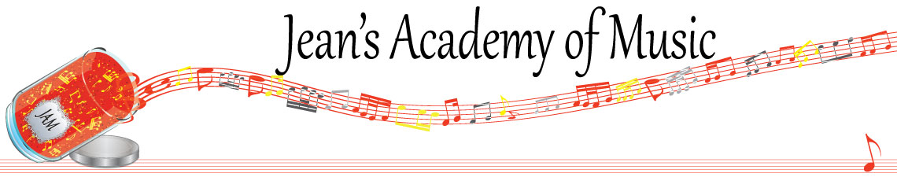
November 2025 “JAM” NEWSLETTER
IMPORTANT DATES TO MAKE NOTE OF:

November 4 RCM exam application deadline for Dec & January in person exams
NOTE CHANGES TO: November 10 - 13 SEMESTER BREAK
*Lessons as per usual for Joey’s studio
*Lessons in effect at Trafalgar for November 12 & 13: makeups from October
*Trafalgar: NO LESSONS NOVEMBER 10 AND 11 (not charged for so no makeups)
November 17 Regular Monday Lessons
November 18 - 20 Group Classes: dates and times below
December 21 Christmas recital
____________________________________________________________________________
Tuition:

- Tuition for lessons is due ON THE 1ST OF EACH MONTH IN ADVANCE unless other arrangements are made.
- NOTE: MASTERCARD, VISA, AND DEBIT ARE STILL AVAILABLE BUT WILL HAVE the percentage added as per the amount I’m charged with Square.
- When setting up eTransfer, please make it repeating for the 1st of each month up to and including June. The tuition is divided up over the 10 months equally for ease of budgeting and simplicity.
- Please look after the tuition without requiring monthly invoices.
- REMEMBER: a late payment fee has been introduced FOR PAYMENTS NOT RECEIVED BY the 15th of the month. This will be a flat fee of $40.00.

NOTE: IN STUDIO/REMOTE LESSONS:
- Masks are mandatory for in studio lessons in the Trafalgar Studio
- Sanitizer will continue to be available at the door upon entry and exit.
- The piano will be cleaned between families.
- If your child or anyone in your home is not well, please let me know and we’ll make arrangements for a remote lesson if necessary.
- Make ups are offered for lessons missed due to being sick but please provide as much notice as possible. Just missing is a forfeit and not eligible for a makeup.
- Do not send coughing and or feverish children to lessons please to either location.
- If the student is well enough to do a remote lesson in place of in person, we’re happy to accommodate that!
ALL FORMS AND PIECES OF INFORMATION ARE ON THE WEBSITE: www.jeanacademy.com
Congratulations to Mahi (38) and Mattias (32.16) the students of the month for October! Great work!! Honorable mention to Marya (32.5) and Eliana (31.13).

There is 1 Student of the Month from each studio. Develop great practice habits to see your name here!
________________________________________________________________________
THERE ARE MANY CHANGES MADE DUE TO CONFLICTS SO PLEASE LOOK OVER THE SCHEDULE AND LET ME KNOW IF THERE ARE PROBLEMS WITH THE NEW TIMES INDICATED.

MASKS ARE MANDATORY FOR GROUP CLASS AT THE TRAFALGAR STUDIO

Tuesday: November 18
3:15 - 4:30 Samiya, Simar, Mahi, Neha, Mireya
4:30 - 5:45 Rachel, Marya, Arya, Jaiden, Myra
5:45 - 7:15 Evan, Jacob, Jonathan, Kai

Wednesday: November 19
3:15 - 4:15 Ruhi, Lola, Maddie, Annelise
4:15 - 5:30 Sajan, Jaeger, Ben, Elijah
5:30 - 7:00 Eliana, Evalie, Lorelei, Theo, Oliver, Zoe

Thursday: November 20
3:15 - 4:30 Mattias, Jack, Kashyap, Isaiah
4:30 - 5:30 Emma, Kacey, Mariam, Reyna, Remi
5:30 - 6:45 Helena, Tuula, Hazel, Diya, Micki

