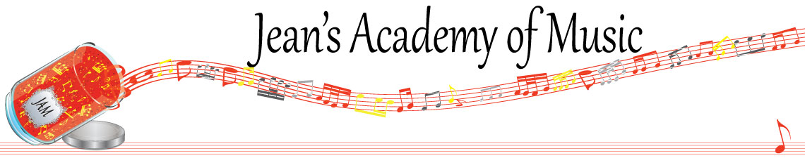
March 2026 “JAM” NEWSLETTER ALBERTA
IMPORTANT DATES TO MAKE NOTE OF:

March 30 - April 6 Spring Break NO LESSONS
____________________________________________________________________________
Tuition:

- Tuition for lessons is due ON THE 1ST OF EACH MONTH IN ADVANCE unless other arrangements are made.
- NOTE: MASTERCARD, VISA, AND DEBIT ARE STILL AVAILABLE BUT WILL HAVE the percentage added as per the amount I’m charged with Square.
- When setting up eTransfer, please make it repeating for the 1st of each month up to and including June. The tuition is divided up over the 10 months equally for ease of budgeting and simplicity. ***soultonesstudio@gmail.com
- Please look after the tuition without requiring monthly invoices.
- REMEMBER: a late payment fee has been introduced FOR PAYMENTS NOT RECEIVED BY the 15th of the month. This will be a flat fee of $40.00.

If you need your piano tuned, I have found a fabulous tuner! Please contact Amadeus Peruch at 780-233-4546 and say I recommended him.

________________________________________________________________________

Here is a little information about how RCM lines up with school grades. Many people have the misconception that if their child is in grade 8 school, they should be in grade 8 piano or violin or whatever other instrument is chosen. The reality is that an RCM exam in level 6 of any disciple with the corresponding theory can be used for a high school grade 10 credit.

The provincial guidelines allow:
RCM 6 plus theory Grade 10 school course
RCM 7 plus theory Grade 11 school course
RCM 8 plus theory Grade 12 school course

Another misconception is the expectation of marks. RCM exams have 60% to pass.
For most levels (formerly called grades) the national average is in the 70s. A mark in
the 80s is fabulous and a mark reaching 90 is in the top 2-3% of the country!

As a studio, we do not push exams for every level because when you are preparing for
an exam, all forward movement is put on hold. No new music is learned because you
simply polish and work to perfect what you’re working on. In my opinion, this is the
death of a student’s love for music! We don’t promote the concept of “exam
students” which means we simply prepare for exam after exam because there is no
life in that process! In my experience it produces students that have certificates but when asked to play something other than exam pieces, they simply can’t. In the JAM studios we work to create life learners and a life of loving music. Our desire is that our students bring music they would like to learn (that isn’t RCM) and find joy in discovering pleasure in simply experiencing a variety of styles and seeing how to apply their skills.

Planning for an exam needs careful consideration in the following areas:
- length of lesson (longer lessons are needed to allow for proper time for ear training and sight reading)(and rehearsing if violin)
- a realistic approach to how much actual practice is needed weekly with a commitment from parents and student
- a well tuned instrument and metronome
- how it fits in with school exam times and or sports playoffs (if January exams are planned for Christmas break is not a break from practice!)
- the family schedule leading up to the exam

Some of you are looking at the possibility of exams moving forward so hopefully this
information will help in your discussions at home. It is a serious commitment that requires the triangle of parent - student - and teacher. We have a 16 week exam preparation plan to complete if you think this is something you wish to pursue .

