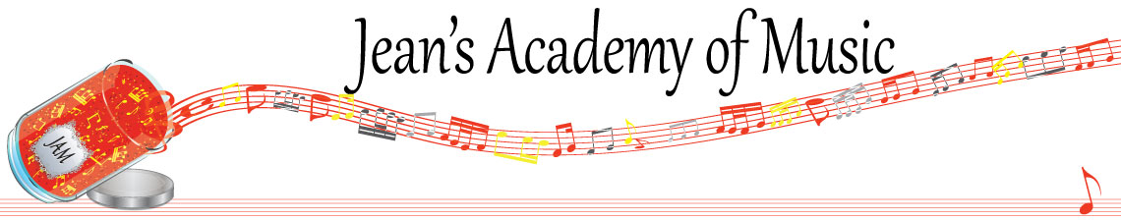
March 2026 “JAM” NEWSLETTER
IMPORTANT DATES TO MAKE NOTE OF:
March 3 RCM exam application deadline for May & June in person exams
March 14 - 29 Spring Break No Scheduled Lessons
March 30 Lessons Resume
April 6 Easter Monday (no scheduled lessons but makeups may take place)
____________________________________________________________________________
Tuition:
- Tuition for lessons is due ON THE 1ST OF EACH MONTH IN ADVANCE unless other arrangements are made.
- NOTE: MASTERCARD, VISA, AND DEBIT ARE STILL AVAILABLE BUT WILL HAVE the percentage added as per the amount I’m charged with Square.
- When setting up eTransfer, please make it repeating for the 1st of each month up to and including June. The tuition is divided up over the 10 months equally for ease of budgeting and simplicity.
- Please look after the tuition without requiring monthly invoices.
- REMEMBER: a late payment fee has been introduced FOR PAYMENTS NOT RECEIVED BY the 15th of the month. This will be a flat fee of $40.00.

NOTE: IN STUDIO/REMOTE LESSONS:
- Masks are mandatory for in studio lessons in the Trafalgar Studio
- If your child or anyone in your home is not well, please let me know and we’ll make arrangements for a remote lesson if necessary.
- Make ups are offered for lessons missed due to being sick but please provide as much notice as possible. Just missing is a forfeit and not eligible for a makeup.
- Do not send coughing and or feverish children to lessons at either location.
- If the student is well enough to do a remote lesson in place of in person, we’re happy to accommodate that!
ALL FORMS AND PIECES OF INFORMATION ARE ON THE WEBSITE: www.jeanacademy.com

Congratulations to Kashyap (43) and Helena (27) the students of the month for February! Great work!!

Honorable mention to:
Neha (35.6)
Rachel (26.88)
Elijah (25.5)

There is 1 Student of the Month from each studio. Develop great practice habits to see your name here!
_______________________________________________________________________

NOTE: There are still a few Christmas books outstanding. Please return!
_______________________________________________________________________

If you need your piano tuned, I have found a fabulous tuner! Please contact Wilhelm Schickgramm (604)760-7743 and say I recommended him.
_______________________________________________________________________

It is the time of year when we begin to consider summer events and activities. Joey and I have spoken and we will be offering a music camp where we will be teaching theory and developing various practical skills as well.

Regular theory summer school will also be offered in preparation for the RCM exams.

Because April is early registration, I have added a page of information to help guide your fall plans regarding length of lessons and realistic expectations.
_______________________________________________________________________

SPEED LIMIT: OUR STRATA COUNCIL HAS COMMENTED THAT VEHICLES ARE NOT ABIDING BY THE SPEED LIMIT. REMEMBER, THIS IS AN AGE RESTRICTED COMPLEX SO MANY PEOPLE ARE NOT QUICK MOVING AND WE WANT EVERYONE SAFE. PLEASE KEEP ME OUT OF THE MINUTES BY NOT BEING ONE OF THE SPEEDERS !
________________________________________________________________________

Here is a little information about how RCM lines up with school grades. Many people have the misconception that if their child is in grade 8 school, they should be in grade 8 piano or violin or whatever other instrument is chosen. The reality is that an RCM exam in level 6 of any disciple with the corresponding theory can be used for a high school grade 10 credit.

The provincial guidelines allow:
RCM 6 plus theory Grade 10 school course
RCM 7 plus theory Grade 11 school course
RCM 8 plus theory Grade 12 school course

Another misconception is the expectation of marks. RCM exams have 60% to pass.
For most levels (formerly called grades) the national average is in the 70s. A mark in
the 80s is fabulous and a mark reaching 90 is in the top 2-3% of the country!

As a studio, we do not push exams for every level because when you are preparing for
an exam, all forward movement is put on hold. No new music is learned because you
simply polish and work to perfect what you’re working on. In my opinion, this is the
death of a student’s love for music! We don’t promote the concept of “exam
students” which means we simply prepare for exam after exam because there is no
life in that process! In my experience it produces students that have certificates but when asked to play something other than exam pieces, they simply can’t. In the JAM studios we want to create life learners and a life of loving music. We want our students to bring music they would like to learn (that isn’t RCM) and find joy in discovering pleasure in simply experiencing a variety of styles and seeing how to apply their skills.

Planning for an exam needs careful consideration in the following areas:
- length of lesson (longer lessons are needed to allow for proper time for ear training and sight reading)
- a realistic approach to how much actual practice is needed weekly with a commitment from parents and student
- a well tuned instrument and metronome
- how it fits in with school exam times and or sports playoffs (if January exams are planned for Christmas break is not a break from practice!)
- the family schedule leading up to the exam

Some of you are looking at the possibility of exams moving forward so hopefully this
information will help in your discussions at home. It is a serious commitment that requires the triangle of parent - student - and teacher. We have a 16 week exam preparation plan to complete if you think this is something you wish to pursue .

