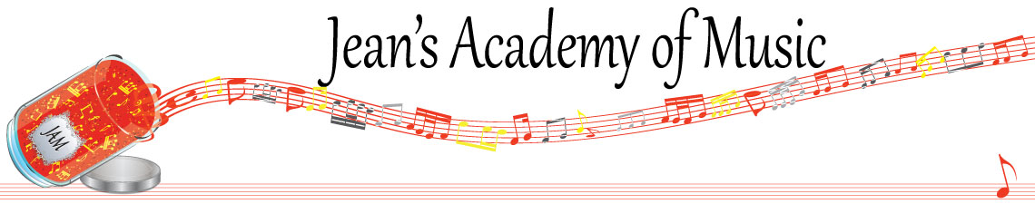
April 2026 “JAM” NEWSLETTER
IMPORTANT DATES TO MAKE NOTE OF:
April 3 Good Friday no lessons
April 6 Easter Monday (no scheduled lessons but makeups may take place)
April 7 - 9 Group classes (see below)
April 30 Early Registration Deadline
____________________________________________________________________________
Tuition:
- Tuition for lessons is due ON THE 1ST OF EACH MONTH IN ADVANCE unless other arrangements are made.
- NOTE: MASTERCARD, VISA, AND DEBIT ARE STILL AVAILABLE BUT WILL HAVE the percentage added as per the amount I’m charged with Square.
- When setting up eTransfer, please make it repeating for the 1st of each month up to and including June. The tuition is divided up over the 10 months equally for ease of budgeting and simplicity.
- Please look after the tuition without requiring monthly invoices.
- REMEMBER: a late payment fee has been introduced FOR PAYMENTS NOT RECEIVED BY the 15th of the month. This will be a flat fee of $40.00.

NOTE: IN STUDIO/REMOTE LESSONS:
- Masks are mandatory for in studio lessons in the Trafalgar Studio
- If your child or anyone in your home is not well, please let me know and we’ll make arrangements for a remote lesson if necessary.
- Make ups are offered for lessons missed due to being sick but please provide as much notice as possible. Just missing is a forfeit and not eligible for a makeup.
- Do not send coughing and or feverish children to lessons at either location.
- If the student is well enough to do a remote lesson in place of in person, we’re happy to accommodate that!
ALL FORMS AND PIECES OF INFORMATION ARE ON THE WEBSITE: www.jeanacademy.com

Congratulations to Kashyap (33.5) and Jonathan & Elijah(28) the students of the month for March! Great work!!

Honorable mention to:
Neha (32.5)
Evan (25.5)
Mireya (25)

There is 1 Student of the Month from each studio unless there is a tie. Develop great practice habits to see your name here!
_______________________________________________________________________

NOTE: There are still a few Christmas books outstanding. Please return!
_______________________________________________________________________

If you need your piano tuned, I have found a fabulous tuner! Please contact Wilhelm Schickgramm (604)760-7743 and say I recommended him.
_______________________________________________________________________

Group Classes:

Tuesday: April 7
3:15 - 4:30 Samiya, Simar, Mahi, Neha Projec ts as discussed in February
4:30 - 5:45 Rachel, Arya, Jaiden, Myra
5:45 - 7:15 Evan, Jacob, Jonathan, Kai

Wednesday: April 8
3:15 - 4:15 Ruhi, Lola, Annelise, Marya, Mariam,
4:15 - 5:30 Sajan, Jaeger, Elijah Projects as discussed in February
5:30 - 6:45 Evalie, Lorelei, Theo

Thursday: April 9
3:15 - 4:30 Mattias, Jack, Isaiah, Kashyap
4:30 - 5:30 Emma, Kacey, Reyna, Remi
5:30 - 6:45 Helena, Tuula, Hazel, Diya, Micki Projects as discussed in February

Missing due to school event: Eliana, Mireya Missing: Maddie
Please contact me if you have a conflict with the time and day for your child(ren).
________________________________________________________________________________________________

EARLY REGISTRATION
We hold your current spot until April 30th, so if you like your time and day of lessons, be sure to get your form in. Beginning May 1, your spot is open for other requests and new students inquiring.
Length of lesson:
- Children, ages 4 and 5, and beginners for year 1 & 2, may have 30 minute lessons although longer lessons are more beneficial.
- In order to foster musical growth, 45 minute music lessons are recommended for students until the completion of RCM Level 4.
- Level 5 to 9 benefit from 60 minute lessons whenever possible.
- Level 10 and ARCT students ideally require 75 – 90 minute lessons if possible.
- Important components such as sight reading and ear training are often sacrificed in shorter lesson times.
- JAM offers two alternate satellite studios. These studios offer guitar, voice, and violin as well as piano. With the strong emergence of virtual lessons, our geographical location is no longer a limitation.

Planning for an exam needs careful consideration in the following areas:
- length of lesson (longer lessons are needed to allow for proper time for ear training and sight reading)
- a realistic approach to how much actual practice is needed weekly with a commitment from parents and student
- a well tuned instrument and metronome
- how it fits in with school exam times and or sports playoffs (if January exams are planned for Christmas break is not a break from practice!)
- the family schedule leading up to the exam

Some of you are looking at the possibility of exams moving forward so hopefully this
information will help in your discussions at home. It is a serious commitment that requires the triangle of parent - student - and teacher. We have a 16 week exam preparation plan to complete if you think this is something you wish to pursue .
_____________________________________________________________________________

The slightly revised studio policy, 26/27 registration forms, summer camp information, and summer theory schedule will be sent within the next couple of days.

