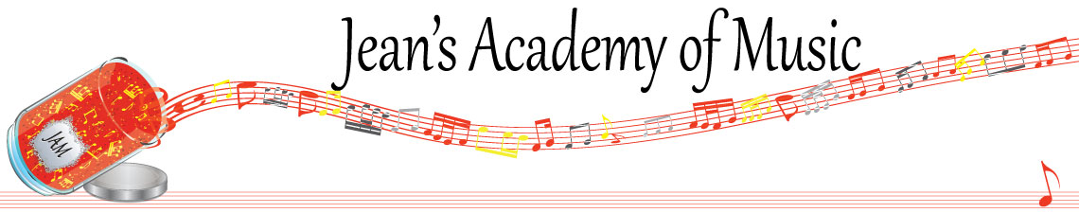
May 2026 “JAM” NEWSLETTER ALBERTA
IMPORTANT DATES TO MAKE NOTE OF:

June 18 Last day of scheduled lessons
____________________________________________________________________________
Tuition:

- Tuition for lessons is due ON THE 1ST OF EACH MONTH IN ADVANCE unless other arrangements are made.
- NOTE: MASTERCARD, VISA, AND DEBIT ARE STILL AVAILABLE BUT WILL HAVE the percentage added as per the amount I’m charged with Square.
- When setting up eTransfer, please make it repeating for the 1st of each month up to and including June. The tuition is divided up over the 10 months equally for ease of budgeting and simplicity. ***soultonesstudio@gmail.com
- Please look after the tuition without requiring monthly invoices.
- REMEMBER: a late payment fee has been introduced FOR PAYMENTS NOT RECEIVED BY the 15th of the month. This will be a flat fee of $40.00.

If you need your piano tuned, I have found a fabulous tuner! Please contact Amadeus Peruch at 780-233-4546 and say I recommended him.
________________________________________________________________________

Length of lesson:
- Children, ages 4 and 5, and beginners for year 1 & 2, may have 30 minute lessons although longer lessons are more beneficial.
- In order to foster musical growth, 45 minute music lessons are recommended for students until the completion of RCM Level 4.
- Level 5 to 8 benefit from 60 minute lessons whenever possible.
- Level 9 through ARCT students ideally require 75 – 90 minute lessons.
- Important components such as sight reading and ear training are often sacrificed in shorter lesson times.

Planning for an exam needs careful consideration in the following areas:
- length of lesson (longer lessons are needed to allow for proper time for ear training and sight reading)
- a realistic approach to how much actual practice is needed weekly with a commitment from parents and student
- a well tuned instrument and metronome
- how it fits in with school exam times and or sports playoffs (if January exams are planned for Christmas break is not a break from practice!)
- the family schedule leading up to the exam

Some of you are looking at the possibility of exams moving forward so hopefully this
information will help in your discussions at home. It is a serious commitment that requires the triangle of parent - student - and teacher. We have a 16 week exam preparation plan to complete if you think this is something you wish to pursue .
________________________________________________________________________
***THESE ARE SUGGESTIONS FOR AVERAGE ADVANCEMENT:

Optimal Practice Duration for Violists at Different Skill Levels
Beginner 20 - 30 minutes daily, short bursts
Intermediate 45 - 1.5 hours daily, structured
Advanced 2+ hours daily, focused
______________________________________________________________________

Optimal Practice Duration for Pianists at Different Skill Levels

LEVEL OF STUDENT | DAILY PRACTICE GOAL (to be achieved 5 days per week)
Beginner: 1st 2 years of study | Practice each item assigned 4x a day
Prep A/B (Alfred level 2A) | Practice each item assigned 5X a day
RCM 1 (Alfred level 2B) | 30 minutes
RCM 2 (Alfred level 3) | 35 minutes
RCM 3 (Alfred level 4) | 40 minutes
RCM 4 (Alfred level 5) | 45 minutes
RCM 5 (Alfred level 6) | 50 minutes
RCM 6 | 55 minutes
RCM 7 | 60 minutes
RCM 8 | 75 minutes
RCM 9 | 90 minutes
RCM 10 | 2 hours

METRONOMES: assist counting out loud…..never replace counting out loud!
They work hand in hand.

