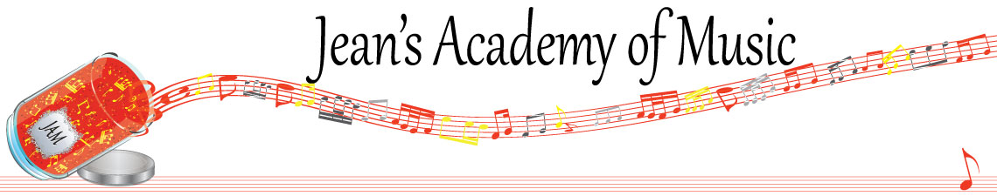
MAY 2026 “JAM” NEWSLETTER
IMPORTANT DATES TO MAKE NOTE OF:

May 18 Victoria Day NO LESSONS
May 19 - 21 Final Group Classes Performance and Party
June 4 Final scheduled lesson day of the year
June 7 Year End Recital Calvin Presbyterian Church
June 8 - 11 Make up lessons (for sickness)
____________________________________________________________________________
Tuition:
- Tuition for lessons is due ON THE 1ST OF EACH MONTH IN ADVANCE unless other arrangements are made.
- NOTE: MASTERCARD, VISA, AND DEBIT ARE STILL AVAILABLE BUT WILL HAVE the percentage added as per the amount I’m charged with Square.
- When setting up eTransfer, please make it repeating for the 1st of each month up to and including June. The tuition is divided up over the 10 months equally for ease of budgeting and simplicity.
- Please look after the tuition without requiring monthly invoices.
- REMEMBER: a late payment fee has been introduced FOR PAYMENTS NOT RECEIVED BY the 15th of the month. This will be a flat fee of $40.00.

NOTE: IN STUDIO/REMOTE LESSONS:
- Masks are mandatory for in studio lessons in the Trafalgar Studio
- If your child or anyone in your home is not well, please let me know and we’ll make arrangements for a remote lesson if necessary.
- Make ups are offered for lessons missed due to being sick but please provide as much notice as possible. Just missing is a forfeit and not eligible for a makeup.
- Do not send coughing and or feverish children to lessons at either location.
- If the student is well enough to do a remote lesson in place of in person, we’re happy to accommodate that!

Congratulations to Neha (35.62) and Lorelei (30.66) the students of the month for April! Great work!!

Honorable mention to:
Arya (34.3)
Mattias (30.17)
Theo (30)

There is 1 Student of the Month from each studio unless there is a tie. Develop great practice habits to see your name here!
_______________________________________________________________________

NOTE: There are still a few Christmas books outstanding. Please return!
_______________________________________________________________________

Group Classes:
***RETURN PERPETUAL TROPHIES;
PLAN TO PERFORM,
BINDER PROJECTS DUE TO SUBMIT FOR HIGHER LEVELS

Tuesday: May 19
3:15 - 4:30 Samiya, Simar, Mahi, Neha, Mireya
4:30 - 5:45 Rachel, Arya, Jaiden
5:45 - 7:15 Evan, Jacob, Jonathan, Kai (binder project)

Wednesday: May 20
3:15 - 4:30 Ruhi, Lola, Annelise, Marya, Mariam,
4:30 - 5:45 Sajan, Jaeger, Elijah, Myra
5:45 - 7:15 Evalie, Lorelei, Theo, Eliana (binder project)

Thursday: May 21
3:15 - 4:30 Mattias, Jack, Isaiah, Kashyap
4:30 - 5:30 Emma, Kacey, Reyna, Remi
5:30 - 6:45 Helena, Tuula, Hazel, Diya, Micki

Please contact me if you have a conflict with the time and day for your child(ren).
________________________________________________________________________________________________

EARLY REGISTRATION: has passed and if you have forgotten to get your registrations in and you want your child(ren) to continue, please do so ASAP. Your current spot may not be available so hurry to secure your desired time!
Length of lesson:
- Children, ages 4 and 5, and beginners for year 1 & 2, may have 30 minute lessons although longer lessons are more beneficial.
- In order to foster musical growth, 45 minute music lessons are recommended for students until the completion of RCM Level 4.
- Level 5 to 9 benefit from 60 minute lessons whenever possible.
- Level 10 and ARCT students ideally require 75 – 90 minute lessons if possible.
- Important components such as sight reading and ear training are often sacrificed in shorter lesson times.
- JAM offers two alternate satellite studios. These studios offer guitar, voice, and violin as well as piano. With the strong emergence of virtual lessons, our geographical location is no longer a limitation.

Planning for an exam needs careful consideration in the following areas:
- length of lesson (longer lessons are needed to allow for proper time for ear training and sight reading)
- a realistic approach to how much actual practice is needed weekly with a commitment from parents and student
- a well tuned instrument and metronome
- how it fits in with school exam times and or sports playoffs (if January exams are planned for Christmas break is not a break from practice!)
- the family schedule leading up to the exam

Some of you are looking at the possibility of exams moving forward so hopefully this
information will help in your discussions at home. It is a serious commitment that requires the triangle of parent - student - and teacher. We have a 16 week exam preparation plan to complete if you think this is something you wish to pursue .
_____________________________________________________________________________

The slightly revised studio policy, 26/27 registration forms, summer camp information, and summer theory schedule are all available at www.jeanacademy.com.

