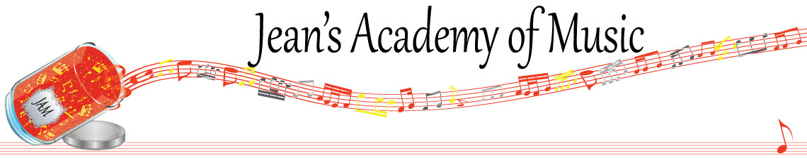
June 2026 “JAM” NEWSLETTER
IMPORTANT DATES TO MAKE NOTE OF:

June 2 RCM exam application deadline for August exams
June 4 Final scheduled lesson day of the year
June 7 Year End Recital: 2:30 Calvin Presbyterian Church
June 8 - 11 Make up lessons (for sickness)
July 6 - 9 Summer Music Camp (see attachments)
August 4 - 6 Summer Music Camp (see attachments)
Summer Theory July 2, 3, 10, 13, 14, 15, 16, 20, 21, 22, 23, 27, 28, 30
August 4, 5
____________________________________________________________________________
Tuition:
- Tuition for lessons is due ON THE 1ST OF EACH MONTH IN ADVANCE unless other arrangements are made.
- Remember there are 10 months of equal payment although there are less lessons in the month of June. You have already received more lessons than you have paid for over the months of September through May.
Extra lessons in the month of June will be invoiced separately. (not the makeups)
- Please look after the tuition without requiring monthly invoices.
- REMEMBER: a late payment fee has been introduced FOR PAYMENTS NOT RECEIVED BY the 15th of the month. This will be a flat fee of $40.00.

Congratulations to Evalie and Jonathan the students of the month for May! Great work!!
_______________________________________________________________________

NOTE: There are still a few Christmas books outstanding. Please return!
_______________________________________________________________________

The slightly revised studio policy, 26/27 registration forms, summer camp information, and summer theory schedule are all available at www.jeanacademy.com.
So why summer piano lessons?

It is a fact that without consistent practice or some maintenance students spend the months from September through November getting to the same position they were at in June. Because we only schedule lessons until the end of the first week of June, there are three full months without scheduled lessons. Booking some lessons during the remainder of June, and some in July and August is actually the perfect way to solidify concepts learned during May. Then rather than losing 6 months you have continuous forward movement without the need for excessive reviewing. This is also a way to capitalize on time when the children aren’t distracted with school and all the extracurricular activities so they have more focused learning and practice. It’s a big “WIN”!

Private piano lessons are offered in Abbotsford with Joey and Jean through the months of June (after June scheduled lessons end), July and the early part of August. Lessons are on a flexible basis to allow for vacations, swimming lessons, and other organized summer activities. We are teaching on Mondays through Thursdays during these months and would love to work with you to help your child stay engaged and inspired! If you haven’t tried these before, here is an opportunity for your child to make progress in their studies!
____________________________________________________________________________
Summer 2026 Music Camp
We are happy to let you know about our plans for music camp at JAM!
Camp will be like group classes in approach & include:
- sight reading
- music history
- ear training
- rhythm
- understanding scales and key signatures
- worked around the age and musical development of the participants
- healthy snacks
____________________________________________________________________________

Summer 2026 Theory
All students RCM Practical Level 3 and higher should take theory.
THEORY 5  Needed for practical Level 5 all disciplines | THEORY 6  Needed for practical Level 6 all disciplines | THEORY 7  Needed for practical Level 7 all disciplines | THEORY 8  Needed for practical Level 8 all disciplines

RCM: theory summer exam registration deadline is June 2nd. The exam dates are: August 7 & 8, 2026. Register at www. rcmusic.ca My teacher number is 04243.
Theory will be offered the following dates and students may attend regardless of the level they are in. You can pick and choose the dates that fit your schedule and instruction will take place tailored to each student’s level and needs. To complete a level of RCM theory takes about 6 2 hour sessions plus review. Each session will include instruction, working time, and marking to ensure the material is being understood. I provide helpful sheets to compliment the theory books.

