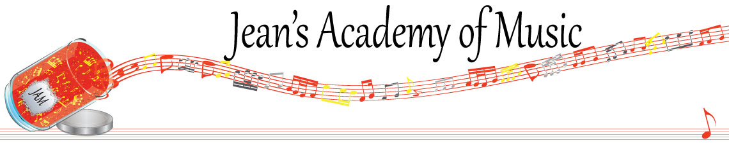
August 2022 “JAM” NEWSLETTER
IMPORTANT DATES TO MAKE NOTE OF:
September 12 Lessons commence
October 10 Thanksgiving Day NO LESSONS
__________________________________________________________________________________________
Tuition
- Tuition for lessons is due at the 1st lesson of September either by CHEQUE, MASTERCARD, VISA, DEBIT, ETRANSFER, or CASH. Not all locations offer debit.
- When paying by credit card, please be sure to come in at the beginning of the month and at the beginning of your child’s lesson time. If you want to have you your number on hand to be charged at the beginning of each month, please note I assume no responsibility for issues that may occur. The office uses Square and the information is stored there only.
- When paying by cheque: ten post-dated cheques are required. (September through June.) The amount will be determined by the office and provided in the registration confirmation letter you will receive in August.
- The cheques should be dated for the first day of each month from September through June inclusive. It is policy that fees are payable in advance unless other arrangements are made with the office.
- Cheques: made payable to Soultones Studio
- Should a cheque be returned from the bank for any reason, JAM will charge the payer $30.00..

Please look after the tuition without requiring monthly invoices. The payment is identical every month. Your equal monthly payment amount will be in the confirmation letter that you will receive within 48 hours after the office receives your registration form and fee as required.

REMINDER: Missed Lessons
- If the student is sick and unable to attend the studio due to the studio guidelines, the lesson can be held at the regular time using one of the following: Skype, FaceTime, or Zoom. If the student is too sick for that, a makeup lesson will be scheduled for another time.
- Make up lessons can be scheduled at the end of lessons in June, during the summer, or at a different time that is mutually convenient. It is your responsibility to make lesson arrangements for that day. Again, you are required to contact the teacher should a makeup lesson be needed.
- IF FAMILY VACATIONS ARE PLANNED FOR TIMES OTHER THAN THE SCHEDULED BREAKS, LESSONS WILL BE FORFEITED and FEES ARE STILL TO BE PAID.
- If a student cannot attend the lesson for reasons other than sickness, the lesson is forfeited unless a “swap” with another student can be arranged.
- If the teacher cannot attend a lesson and is unable to arrange an alternate time or substitute, the office will refund the fee for that lesson.
__________________________________________________________________________

REGISTRATION FORM 2022 / 2023
Please complete and return this form accompanied by the registration fee of $30.00 for each individual or $60.00 per family.
The registration fees are non-refundable.
Please read the policy carefully.
Your signature on this form indicates your acceptance of the policy.

FOR CONFIRMATION OF LESSONS THE OFFICE MUST HAVE BOTH THE REGISTRATION FORM AND FEE UNLESS INDIVIDUAL ARRANGEMENTS ARE MADE.

____________________________________________________________________________________
Technique Olympics
- November 15 - 17
- a competition in technique, sight reading, and ear testing and theory.
- This event replaces regular lessons for that week. (Except for the Monday students)
____________________________________________________________________________

Please visit: www.jeanacademy.com for all the information such as policy etc.

Please contact the office: jeanacademy@gmail.com and tdoerksen8@gmail.com if you have any questions or concerns.

