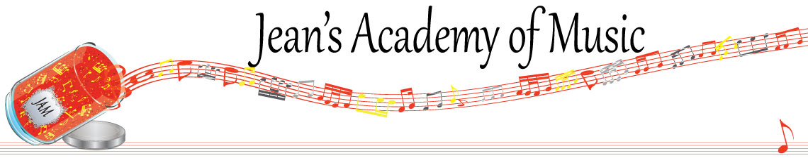
October 2022 “JAM” NEWSLETTER
IMPORTANT DATES TO MAKE NOTE OF:
October 10 Thanksgiving Day NO LESSONS
November 1 RCM exam application deadline for Dec & Jan in person exams
__________________________________________________________________________________________
Tuition
- Tuition for lessons is due on the 1st of October unless other arrangements have been made directly with Teresa or Jean.
- either by CHEQUE, MASTERCARD, VISA, DEBIT, ETRANSFER, or CASH. Not all locations offer debit.

Please look after the tuition without requiring monthly invoices. It’s easy to set up as a repeating eTransfer with your bank account making the final payment June 1, 2023.

I realize September is a busy month and some of you have overlooked September’s payment. Please attend to this and add it to your October payment.

Students of the Month: September was a month of much adjustment as students returned to school and were trying to establish a rhythm in their practice and other activities so I am reserving the right to not have official students of the month for September. However I wish to acknowledge some amazing effort by the following students:
Addison Moylan and Anna Affolter

I’m looking forward to recognizing students of the month in October!

_____________________________________________________________________________

For information regarding “JAM” please visit: www.jeanacademy.com

Questions can either be addressed to Teresa or Jean.

