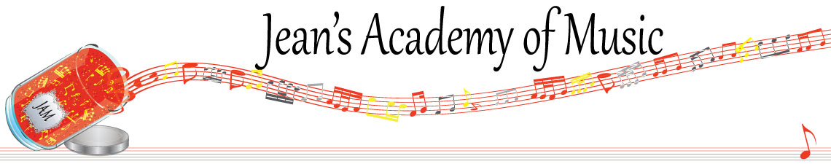
October 2022 “JAM” NEWSLETTER
IMPORTANT DATES TO MAKE NOTE OF:
October 10 Thanksgiving Day NO LESSONS
November 1 RCM exam application deadline for Dec & Jan in person exams
__________________________________________________________________________________________
Tuition
- Tuition for lessons is due at the 1st lesson of October either by CHEQUE, MASTERCARD, VISA, DEBIT, ETRANSFER, or CASH. Not all locations offer debit.

Please look after the tuition without requiring monthly invoices. It’s easy to set up as a repeating eTransfer with your bank account making the final payment June 1, 2023.

I realize September is a busy month and some of you have overlooked September’s payment. We all want to receive our paycheques in a timely manner! Therefore, beginning in November, a late payment fee will be added to overdue accounts.

NOTE: IN STUDIO/REMOTE LESSONS: please continue to observe (Trafalgar St)
Students are welcome in the studio if the following requirements are met:
1. No one in your household is ill
2. The student is well
3. No one in your household has Covid or has been in contact with a Covid positive person
4. Masks are worn at all times
5. Sanitizer is used

Students of the Month: September was a month of much adjustment as students returned to school and were trying to establish a rhythm in their practice and other activities so I am reserving the right to not have official students of the month for September. However I wish to acknowledge some amazing effort by the following students:
Sajan Banwait, Jacob Leonard, Kaya Brar, and Kai Antunes

I’m looking forward to recognizing students of the month in October!

CFMTA CANADA MUSIC WEEK POSTER COMPETITION IS NOW OPEN!
CFMTA is calling all student artists to submit their artwork to be displayed on the 2023 Canada Music Week® Poster!
Artwork must be an original work of the student, studying with a current CFMTA member and will be open to all students aged 18 and under. The student should consider the theme “Canadian Geography” in their artwork.
Student artists are asked to submit their artwork, with their name, email, phone number, teacher and province by November 15th. Suggested size 15cm x 15 cm (6 inches x 6 inches)
Winning artist will be acknowledged.
For more information, email canadamusicweek@cfmta.org

