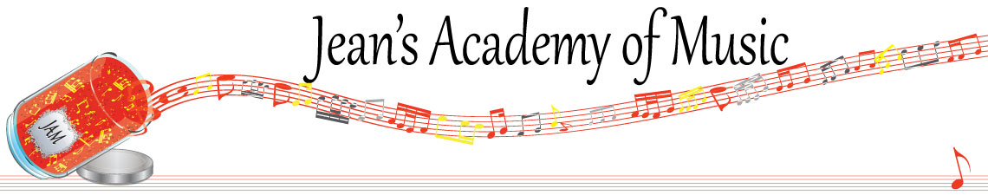
November 2022 “JAM” NEWSLETTER
IMPORTANT DATES TO MAKE NOTE OF:
November 8 RCM exam application deadline for Dec & Jan in person exams
December 9 & 10 RCM Theory Exams
December 24 – January 8 Christmas Break NO LESSONS
__________________________________________________________________________________________
Tuition
- Tuition for lessons is due at the 1st lesson of November either by CHEQUE, MASTERCARD, VISA, DEBIT, ETRANSFER, or CASH. Not all locations offer debit.

Please look after the tuition without requiring monthly invoices. It’s easy to set up as a repeating eTransfer with your bank account making the final payment June 1, 2023.

REMEMBER: beginning in November, a late payment fee will be added to overdue accounts.

Students of the Month: I am proud of how hard the students are working and am excited about new habits being created! I have 4 subdivisions of students this year so October students of the month are: Vivienne, Helena, Evan, and Tobias!

Congratulations to these four as well as Evalie Melnychuk from the Lobban Rd location!!

The Edmonton studio has awarded students of the month to Levi Sulimma for piano and Elena Varbanova for violin. Congratulations!

Stand out by always counting aloud and saying your opening notes and finger numbers! Use proper fingering and make music!! Remember those curved fingers in all your playing.

Christmas music: students will be starting Christmas music shortly

REMINDER: make up lessons are only offered for sickness and family deaths. Birthday parties and other reasons for missing lessons don’t qualify for make ups. Thanks for your understanding. (policy can be found at www.jeanacademy.com)

