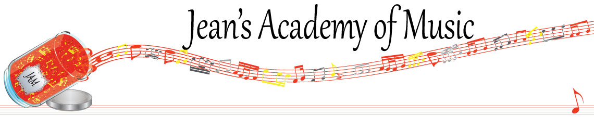
November 2022 “JAM” NEWSLETTER
IMPORTANT DATES TO MAKE NOTE OF:
November 8 RCM exam application deadline for Dec & Jan in person exams
November 14 Regular lessons
November 15 - 17 Group Classes: Technique Olympics (Trafalgar Studio only)
December 9 & 10 RCM Theory Exams
December 17 (to be confirmed) In- Person Christmas Recital at the Tabor Home 2:00 P.M.
December 18 - January 2 Christmas Break
__________________________________________________________________________________________
Tuition
- Tuition for lessons is due at the 1st lesson of November either by CHEQUE, MASTERCARD, VISA, DEBIT, ETRANSFER, or CASH. Not all locations offer debit.

Please look after the tuition without requiring monthly invoices. It’s easy to set up as a repeating eTransfer with your bank account making the final payment June 1, 2023.

REMEMBER: beginning in November, a late payment fee will be added to overdue accounts.

NOTE: IN STUDIO/REMOTE LESSONS: please continue to observe (Trafalgar St)
Students are welcome in the studio if the following requirements are met:
1. No one in your household is ill
2. The student is well
3. No one in your household has Covid or has been in contact with a Covid positive person
4. Masks are worn at all times
5. Sanitizer is used

Students of the Month: I am proud of how hard the students are working and am excited about new habits being created! I have 4 subdivisions of students this year so October students of the month are: Vivienne, Helena, Evan, and Tobias! Congratulations to these four as well as Evalie Melnychuk from the Lobban Rd location!!

Stand out by always counting aloud and saying your opening notes and finger numbers! Use proper fingering and make music!! Remember those curved fingers in all your playing.

GROUP CLASS SCHEDULE: (Trafalgar Studio)

NOTE: THERE ARE CHANGED TIMES FOR SOME GROUPS

PLEASE REMIND:
***all students to bring their Theory Books to group if they aren’t kept here
*** all students to bring their music books and to be prepared to play for their group
***all students that their technique is being tested in the group class…..REVIEW TECHNIQUE COVERED SO FAR!
***Students Level 3 and up have composer research project due at their group class.

Tuesday November 15:
3:15 - 4:30 Simar, Samiya, Madison, Grace
4:30 - 6:00 Sajan, Mason, Ethan, Ben
6:45 - 8:15 Tobias, Isaac

Wednesday November 16:
3:15 - 5:15 Anja, Alex, Kai, Govind
5:15 - 7:15 Lorelei, Alyssa, Kaya, Ameera, Violet

Thursday November 17:
3:15 - 5:15 Evan, Rory, Jacob, Oliver, Atticus
5:15 - 6:45 Jocelyn, Helena, Hazel, Tuula, Vivienne

STUDENTS NOT IN GROUP: Lexi, Aleaya

Christmas music: students will be starting Christmas music this week in preparation for our in person Christmas recital! In order to accommodate as many students wanting to play as possible, siblings will be playing duets. THE HOME WE’RE INVITED TO DOES REQUIRE COVID VACCINATION!
*** Jenica’s students are invited to participate in this recital if desired!
______________________________________________________________________
REMINDER: make up lessons are only offered for sickness and family deaths. Birthday parties and other reasons for missing lessons don’t qualify for make ups. Thanks for your understanding. (policy can be found at www.jeanacademy.com)

