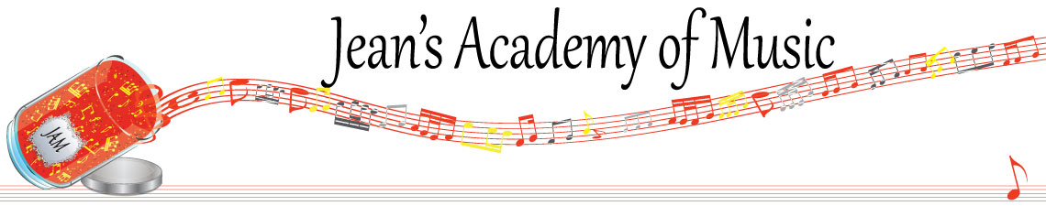
December 2022 “JAM” NEWSLETTER
IMPORTANT DATES TO MAKE NOTE OF:

December 17 Christmas Performance 10:00 a.m. (details below)
December 18 - January 8 Christmas Break
January 9 Lessons Resume
__________________________________________________________________________________________
Tuition
- Tuition for lessons is due at the 1st of December either by CHEQUE, MASTERCARD, VISA, DEBIT, ETRANSFER, or CASH. Not all locations offer debit.
Please look after the tuition without requiring monthly invoices.
REMEMBER: beginning in November, a late payment fee will be added to overdue accounts.

Students of the Month:

November student of the month is Taya Sorenson.

Stand out by always counting aloud and saying your opening notes and finger numbers! Use proper fingering and make music!! Remember those curved fingers in all your playing.

CHRISTMAS CONCERTS:

A detailed group email will be sent out next weekend with all the final details for the performance opportunity on December 17th at 10:00 a.m..

______________________________________________________________________
REMINDER: make up lessons are only offered for sickness and family deaths. Birthday parties and other reasons for missing lessons don’t qualify for make ups. Thanks for your understanding. (Policy can be found at www.jeanacademy.com)
______________________________________________________

