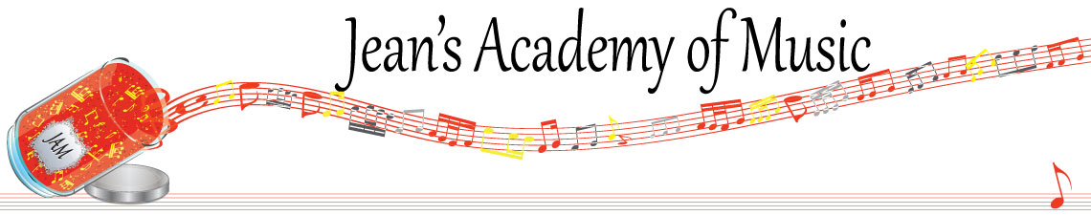
December 2022 “JAM” NEWSLETTER
IMPORTANT DATES TO MAKE NOTE OF:

December 17 In- Person Christmas Recital at the Tabor Home 2:00 P.M.
December 17 In - Person JAM Studio Christmas Recital at 6:30 p.m.
December 19 Makeup lessons (Trafalgar Studio)
December 18 - January 2 Christmas Break
January 3 Lessons Resume
January 16 Regular Lessons
January 17 - 19 Group Classes (schedule will be sent in the January newsletter)
__________________________________________________________________________________________
Tuition
- Tuition for lessons is due at the 1st lesson of December either by CHEQUE, MASTERCARD, VISA, DEBIT, ETRANSFER, or CASH. Not all locations offer debit.
Please look after the tuition without requiring monthly invoices.
REMEMBER: beginning in November, a late payment fee will be added to overdue accounts.

NOTE: IN STUDIO/REMOTE LESSONS: please continue to observe (Trafalgar St)
Students are welcome in the studio if the following requirements are met:
1. No one in your household is ill
2. The student is well
3. No one in your household has Covid or has been in contact with a Covid positive person
4. Masks are worn at all times
5. Sanitizer is used
I TRULY APPRECIATE THE RESPECT YOU ALL SHOW BY NOT COMING HERE SICK!!

Students of the Month: I am proud of how hard the students are working and am excited about new habits being created! I have 4 subdivisions of students this year so November students of the month are: Tuula, Ben, Jacob, and Isaac! Congratulations to these four as well as Arya Singh from the Lobban Rd location!!

Stand out by always counting aloud and saying your opening notes and finger numbers! Use proper fingering and make music!! Remember those curved fingers in all your playing.

NOTE: LOBBAN RD PARKING…….NO PARKING ON THE DRIVEWAY PLEASE AS REQUESTED BY THE OWNERS.

TRAFALGAR STUDIO: PLEASE DROP OFF AND PICK UP YOUR CHILDREN AT THE FRONT DOOR IF LESSONS ARE AFTER DUSK…….WE HAVE BEEN DEALING WITH A BLACK BEAR IN THE COMPLEX.

CHRISTMAS CONCERTS: for all students at the Trafalgar St. and Lobban Rd. locations

There are 2 concerts:
- 1 at the Tabor Home for students and parents with 2 vaccinations. Masks are required as well.
- 1 at the Trafalgar St address for unvaccinated students. Masks are required for all in attendance.
- Tabor Home: December 17, 2:00 p.m. 31944 Sunrise Crescent, Abbotsford
- JAM Studio: December 17, 6:30 p.m. 42 3054 Trafalgar St. Please use visitor and street parking.
- PLEASE RSVP TO JEAN WHETHER OR NOT YOUR CHILD(REN) IS PLAYING. EMAIL NAMES OF CHILDREN, WHICH CONCERT, AND HOW MANY WILL BE ATTENDING. UNFORTUNATELY THERE ISN’T ENOUGH ROOM IN THE JAM STUDIO FOR EXTRA GUESTS.
______________________________________________________________________
REMINDER: make up lessons are only offered for sickness and family deaths. Birthday parties and other reasons for missing lessons don’t qualify for make ups. Thanks for your understanding. (policy can be found at www.jeanacademy.com) ____________________________________________________________
Makeup lessons: (Trafalgar St. studio students)
I am willing to offer makeup lessons to the following students that have missed lessons due to illness on December 19th during the daytime to those of you interested in a lesson that day between 10:00 a.m. and 5:00 p.m. on a first come first serve basis.
Students: Tobias, Simar, Madison, Mason, Jocelyn, Grace, Ethan
______________________________________________________

