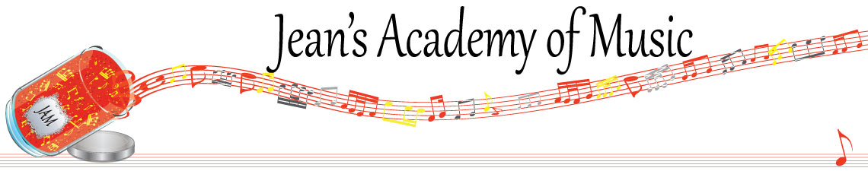
January 2023 “JAM” NEWSLETTER
IMPORTANT DATES TO MAKE NOTE OF:

January 9 Lessons Resume
February 20 Family Day NO LESSONS
__________________________________________________________________________________________
Tuition: Tuition for lessons is due January 1st: either by CHEQUE, MASTERCARD, VISA, DEBIT, ETRANSFER, or CASH. Not all locations offer debit.
Please look after the tuition without requiring monthly invoices.

REMEMBER: beginning in November, a late payment fee will be added to overdue accounts.

Students of the Month: December students of the month are: HarlowBeau Parino and Ayden Sulimma! Congratulations! This was an extremely difficult decision this month because so many students are improving. Honourable mention goes to: Maddix Tooms, Elena Varbanova, Hudson Eaton and Anna Affolter!

Stand out by always counting aloud and saying your opening notes and finger numbers! Use proper fingering and make music!! Remember those curved fingers in all your playing.
____________________________________________________________________________
REMINDER: make up lessons are only offered for sickness and family deaths. Birthday parties and other reasons for missing lessons don’t qualify for make ups. Thanks for your understanding. (Policy can be found at www.jeanacademy.com)
In our busy lives we often have conflicts arise, but please remember that as teachers our lives have more in them than teaching and we have busy schedules as well. We do our best not to mess with the lesson schedules unless absolutely necessary so we request that you also respect our lives by limiting your requests for changed lesson times unless you have an emergency. Thank you . ______________________________________________________________________
Happy New Year!

