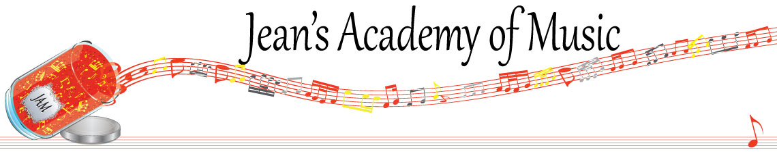
February 2023 “JAM” NEWSLETTER
IMPORTANT DATES TO MAKE NOTE OF:

February 20 Family Day NO LESSONS
March 7 RCM exam application deadline for May and June in person exams
March 25 - April 3 Spring Break NO LESSONS
__________________________________________________________________________________________
Tuition: Tuition for lessons is due February 1st: either by CHEQUE, MASTERCARD, VISA, DEBIT, ETRANSFER, or CASH. Not all locations offer debit.
Please look after the tuition without requiring monthly invoices.

REMEMBER: a late payment fee has been introduced to overdue accounts.

Students of the Month: With January being a short month, the student of the month designation has not been applied. Perhaps more students will stand out in February?

Stand out by always counting aloud and saying your opening notes and finger numbers! Use proper fingering and make music!! Remember those curved fingers in all your playing.
____________________________________________________________________________
REMINDER: make up lessons are only offered for sickness and family deaths. Birthday parties and other reasons for missing lessons don’t qualify for make ups. Thanks for your understanding. (Policy can be found at www.jeanacademy.com)
In our busy lives we often have conflicts arise, but please remember that as teachers our lives have more in them than teaching and we have busy schedules as well. We do our best not to mess with the lesson schedules unless absolutely necessary so we request that you also respect our lives by limiting your requests for changed lesson times unless you have an emergency. Thank you . ______________________________________________________________________

