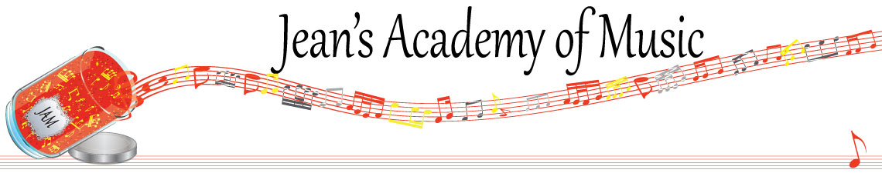
February 2023 “JAM” NEWSLETTER
IMPORTANT DATES TO MAKE NOTE OF:

February 20 Family Day NO LESSONS
February 27 Regular Lessons (EVEN THOUGH THERE IS GROUP THIS WEEK)
February 28, March 1 -2 Group Classes (see schedule below)
March 7 RCM exam application deadline for May and June in person exams
March 13 - March 26 Spring Break
June 3 Year- end Recital Mark your calendars
__________________________________________________________________________________________
Tuition
- Tuition for lessons is due at the 1st lesson of February either by CHEQUE, MASTERCARD, VISA, DEBIT, ETRANSFER, or CASH. Not all locations offer debit.
Please look after the tuition without requiring monthly invoices.
REMEMBER: a late payment fee has been introduced to overdue accounts.

NOTE: IN STUDIO/REMOTE LESSONS: please continue to observe (Trafalgar St)
Students are welcome in the studio if the following requirements are met:
1. No one in your household is ill
2. The student is well
3. No one in your household has Covid or has been in contact with a Covid positive person
4. Masks are worn at all times
5. Sanitizer is used
I TRULY APPRECIATE THE RESPECT YOU ALL SHOW BY NOT COMING HERE SICK!!

Students of the Month: I am proud of how hard the students are working! January students of the month are: Simar, Atticus, Evan, Anja, and Isaac! Congratulations to these students as well as Lexi Price from the Lobban Rd location!!

Stand out by always counting aloud and saying your opening notes and finger numbers! Use proper fingering and make music!! Remember those curved fingers in all your playing.
____________________________________________________________________________

NOTE: LOBBAN RD PARKING…….NO PARKING ON THE DRIVEWAY PLEASE AS REQUESTED BY THE OWNERS.

February 28, March 1 & 2 GROUP CLASSES: (Trafalgar studio only)
Note the highlighted changes made to accommodate ensemble practice

Tuesday February 28:
3:15 - 4:30 Simar, Madison, Grace, Samiya
4:30 - 6:00 Mason, Ethan, Ben, Sajan
6:30 - 8:00 Tobias and Isaac

Wednesday March 1:
3:15 - 5:15 Anja, Alex, Kai, Govind, Jonathan
5:15 - 6:45 Ameera, Violet
5:45 - 7:15 Lorelei, Alyssa, Kaya

Thursday March 2:
3:15 - 4:45 Evan, Jacob, Atticus
3:45 - 5:15 Rory, Oliver
5:15 - 6:30 Jocelyn, Hazel
5:30 - 6:45 Helena, Tuula, Vivienne

STUDENTS NOT IN GROUP: Lexi, Aleaya

PLEASE NOTIFY OF CONFLICTS ASAP
_______________________________________________________________________________________
REMINDER: make up lessons are only offered for sickness and family deaths. Birthday parties and other reasons for missing lessons don’t qualify for make ups. Thanks for your understanding. (Policy can be found at www.jeanacademy.com)
In our busy lives we often have conflicts arise, but please remember that as teachers our lives have more in them than teaching and we have busy schedules as well. We do our best not to mess with the lesson schedules unless absolutely necessary so we request that you also respect our lives by limiting your requests for changed lesson times unless you have an emergency. Thank you .
______________________________________________________________________

