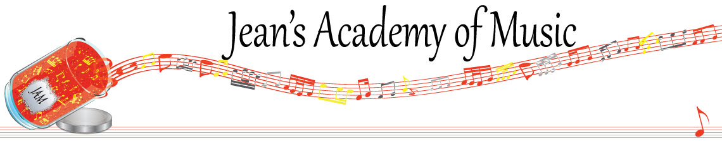
March 2023 “JAM” NEWSLETTER
IMPORTANT DATES TO MAKE NOTE OF:

March 7 RCM exam application deadline for May and June in person exams
March 13 - March 26 Spring Break NO LESSONS
March 27 Lessons Resume
April 10 Easter Monday NO LESSONS
April 30 Early Registration Deadline
June 4 Year- end Recital NOTE THE CHANGE FROM THE 3RD
__________________________________________________________________________________________
Tuition
- Tuition for lessons is due at the 1st lesson of March either by CHEQUE, MASTERCARD, VISA, DEBIT, ETRANSFER, or CASH. Not all locations offer debit.
Please look after the tuition without requiring monthly invoices.
REMEMBER: a late payment fee has been introduced to overdue accounts on the 15th of the month.

NOTE: IN STUDIO/REMOTE LESSONS: please continue to observe (All Locations)
Students are welcome in the studio if the following requirements are met:
1. The student is well.
2. Masks are worn at all times
3. Sanitizer is used
WE TRULY APPRECIATE THE RESPECT YOU ALL SHOW BY NOT COMING TO LESSONS SICK!!

Students of the Month: I am proud of how hard the students are working! Students of the month are: Jacob and Kai! Congratulations to these students as well as Annelise from the Lobban Rd location!!

Stand out by always counting aloud and saying your opening notes and finger numbers! Use proper fingering and make music!! Remember those curved fingers in all your playing.
____________________________________________________________________________

NOTE: LOBBAN RD PARKING…….NO PARKING ON THE DRIVEWAY PLEASE AS REQUESTED BY THE OWNERS.

In brainstorming with my daughter and granddaughter we discussed the idea of using this newsletter for a platform to clarify some of the reasons we do things a specific way. This month it is how we count.
Counting Explanation:
It was common practice for musicians of certain generations to count using 1+ 2+3+4+. As with many things, changes have taken place to help young students to be able to count with greater understanding and accuracy. Our brains are all wired differently and teaching has adapted to work with this. I cannot even recall when rhythm words were first introduced because that is what I have used for the last 25 years at least! Why rhythm words? Why not? Why can’t a set of eighth notes be counted “puppy” or any other 2 syllable word? Why does it have to be 1+? It doesn’t! I find a triplet followed by a quarter note is counted perfectly with “blueberry pie”. This eliminates the pause between the triplet and quarter that is commonly found in counting and actually makes the triplet move to the next beat as it is designed to. I always found the “1e+a” to be a mouthful! We prefer: avocado, watermelon, or huckleberry.
For students doing music in school we support the use of “ta” and “titi” etc.
Many teachers continue to count the old way and it can work. I have reviewed new music books and methods for teacher magazines for many years. The trend has been away from numbers unless you’re counting time signatures with a base of 8: 3/8, 6/8 etc.
Much of the key to rhythm is the understanding of fractions. I have found this a struggle for many children. As teachers, we are tasked with finding ways to simplify challenges and promote success.
I’m grateful for parents’ input and involvement in their children’s music education. We want your support in practice! However, if you see us using rhythm words in our instructions, please don’t confuse them by trying to make them count 1+2+ etc. Jean’s Academy supports the use of the metronome AFTER the child has learned to count aloud. Until that habit is established, the metronome is often used to replace counting and when the pressures of performance or exams come, the student is lost: no counting, no metronome, and poor rhythm!
I welcome your questions or comments! We all want to promote success and joy in music making!

______________________________________________________________________
NEWSFLASH!
1. We are looking into the possibility of offering music camp during the summer to promote retaining information learned over the course of the year. Activities would include note reading, rhythm, composing, crafts and more! Stay tuned……

2. Theory classes will be available during the summer months to prepare for RCM theory exams. Details should be available sometime in April.
______________________________________________________________
REMINDER: make up lessons are only offered for sickness and family deaths. Birthday parties and other reasons for missing lessons don’t qualify for make ups. Thanks for your understanding. (Policy can be found at www.jeanacademy.com)
In our busy lives we often have conflicts arise, but please remember that as teachers our lives have more in them than teaching and we have busy schedules as well. We do our best not to mess with the lesson schedules unless absolutely necessary so we request that you also respect our lives by limiting your requests for changed lesson times unless you have an emergency. Thank you.

