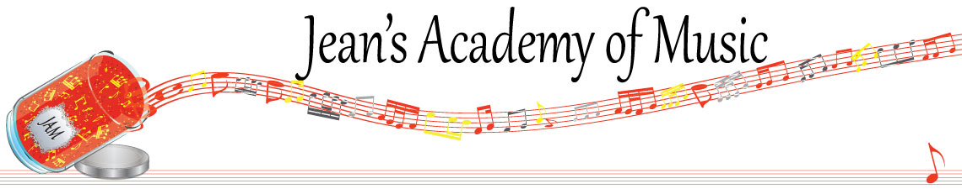
April 2023 “JAM” NEWSLETTER
IMPORTANT DATES TO MAKE NOTE OF:

April 10 Easter Monday NO LESSONS
April 30 Early Registration Deadline
May 22 Victoria Day NO LESSONS
May 23 - 25 Group Classes Details to follow
June 4 Year- end Recital
__________________________________________________________________________________________
Tuition
- Tuition for lessons is due at the 1st lesson of April either by CHEQUE, MASTERCARD, VISA, DEBIT, ETRANSFER, or CASH. Not all locations offer debit.
Please look after the tuition without requiring monthly invoices.
REMEMBER: a late payment fee has been introduced to overdue accounts on the 15th of the month.

NOTE: IN STUDIO/REMOTE LESSONS: please continue to observe (All Locations)
- Students are welcome in the studio and/or are eligible for home lessons if the student is well.
- Make ups are offered for lessons missed due to being sick.
- If the student is well enough to do a remote lesson in place of in person, we’re happy to accommodate that!
- All three of us teachers have various health issues that leave us vulnerable, so WE TRULY APPRECIATE THE RESPECT YOU ALL SHOW BY NOT COMING TO LESSONS SICK!!

Students of the Month: I am proud of how hard the students are working! Students of the month are: Jonathan and Lexi! Congratulations to these students!

Stand out by always counting aloud and saying your opening notes and finger numbers! Use proper fingering and make music!! Remember those curved fingers in all your playing.
____________________________________________________________________________

NOTE: LOBBAN RD PARKING…….NO PARKING ON THE DRIVEWAY PLEASE AS REQUESTED BY THE OWNERS.

EARLY REGISTRATION DETAILS:
- Completed form and registration fee secure a spot for the fall.
- Until April 30th, you are guaranteed a lesson spot after that we open it up to the waiting list and public.
- Please review the length of time you need for your child(ren)
- It is recommended that 30 minutes are only for Beginners years 1 and 2.
- 3rd year Beginners up to and including RCM Level 4 need 45 minutes. (equal to Premier Level 5)
- Students in RCM Level 5 and up benefit from 60 - 75 minute lessons.
__________________________________________________________________________________________
LESSONS EXPLANATION….WHY LENGTHS OF LESSONS MAKE A DIFFERENCE:
In order to create a well-rounded musician, lessons should include technique…..scales, chords, etc. These are essential for developing and strengthening the hand of the student. You should also hear warm ups and exercises. All of this is critical to prevent injury and poor playing habits. Check the hand position of your pianist and see if fingers are curved and the bridge of the hand is up or caved in. Without proper finger and hand position development the student will be disadvantaged and will never be able to play with proper speed and fluency! Doing these activities will take between 5 and 15 minutes of a lesson depending on preparation and level.

We need to be able to work on ear training and sight reading in a lesson. This easily takes up to 5 minutes of a lesson. Often these are skipped when lessons aren’t long because students get frustrated when the teacher doesn’t have enough time to hear their music. In an exam, these two areas make up 20% of it! When prepared well, these are basically 20 free marks!

Many times lessons require revisiting how to practice correctly. It would be amazing if students only built awesome practice habits! They all know they are to learn new music hands separately but that frequently isn’t the case. Then we find incorrect fingering and rhythm because frankly they aren’t far enough and trained enough to be able to take that all in……their focus is notes and “how does this sound?” Of course, then there is desire to play everything fast long before they are able. When I make them go half the speed they began with I am told they can’t play correctly when it that slow….amazing…..that should be their moment to shine and show that they can actually play the piece. Slow and counting aloud…..think 10x, play once……is what is talked about in almost every lesson. The tragic thing is that to undo an incorrect note that has been misplayed 15 times takes 105 correct repetitions to undo it……each time of playing something wrong once takes 7 reps to undo. But the worst part is when the student is under pressure in a performance, that original error resurfaces 9 out of 10 times! When you hear stumbling and fumbling along, perhaps you can question their practice and find out if they are playing or practicing…..big difference between the two!!

Students need to be taught how to memorize correctly…….playing it 50 times doesn’t a secure performance make! Often I record what a student is playing so that they can actually hear that there are no dynamics, incorrect rhythm, and altered tempo at the more challenging spots. Without that, they aren’t aware of what they’re doing. All of this takes time!

So when your child(ren) complain about not getting through everything in the lesson there are many reasons. When we request check marks on the practice sheet, it isn’t because we can’t accurately determine the amount that has been practiced; it is for them to be accountable to themselves. Yes, sometimes we get sheets with everything marked well practiced, but alas, in some cases there is fabrication and we can tell. For the lessons where the student is well prepared, we move along well and can cover most of what should take place in each lesson.

If you have questions regarding anything you’ve read, feedback is always welcome!!
______________________________________________________________________
NEWSFLASH!
1. We are looking into the possibility of offering music camp during the summer to promote retaining information learned over the course of the year. Activities would include note reading, rhythm, composing, crafts and more! Stay tuned……

2. Theory classes will be available during the summer months to prepare for RCM theory exams. Details should be available sometime in April. This is currently being worked on.
______________________________________________________________
REMINDER: make up lessons are only offered for sickness and family deaths. Birthday parties and other reasons for missing lessons don’t qualify for make ups. Thanks for your understanding. (Policy can be found at www.jeanacademy.com)
In our busy lives we often have conflicts arise, but please remember that as teachers our lives have more in them than teaching and we have busy schedules as well. We do our best not to mess with the lesson schedules unless absolutely necessary so we request that you also respect our lives by limiting your requests for changed lesson times unless you have an emergency. Thank you.

