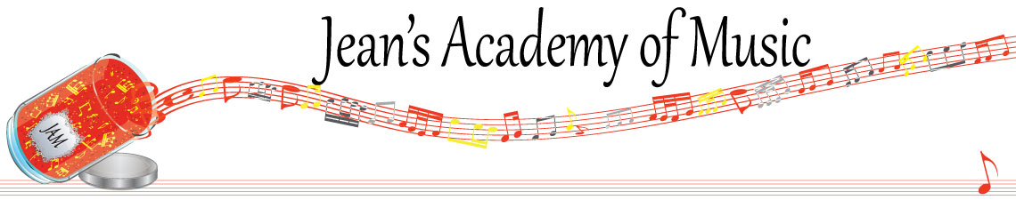
May 2023 “JAM” NEWSLETTER
IMPORTANT DATES TO MAKE NOTE OF:

April 30 Early Registration Deadline for 2023 - 2024 lessons
May 22 Victoria Day NO LESSONS
TBA Year- end Recital
June 6 RCM registration deadline for August Exams
June 9 Final scheduled lesson day of the year
June 12 onward as needed Make up Lesson Days
__________________________________________________________________________________________
Tuition: Tuition for lessons is due May 1st: either by CHEQUE, MASTERCARD, VISA, DEBIT, ETRANSFER, or CASH. Not all locations offer debit.
Please look after the tuition without requiring monthly invoices.

REMEMBER: a late payment fee has been introduced to overdue accounts on the 15th of the month.

NOTE: IN STUDIO/REMOTE LESSONS: please continue to observe (All Locations)
- Students are welcome in the studio and/or are eligible for home lessons if the student is well.
- Make ups are offered for lessons missed due to being sick.
- If the student is well enough to do a remote lesson in place of in person, we’re happy to accommodate that!
- All three of us teachers have various health issues that leave us vulnerable.
WE TRULY APPRECIATE THE RESPECT YOU ALL SHOW BY NOT COMING TO LESSONS SICK!!
REMINDER: make up lessons are only offered for sickness and family deaths. Birthday parties and other reasons for missing lessons don’t qualify for make ups. Thanks for your understanding. (Policy can be found at www.jeanacademy.com)
In our busy lives we often have conflicts arise, but please remember that as teachers our lives have more in them than teaching and we have busy schedules as well. We do our best not to mess with the lesson schedules unless absolutely necessary so we request that you also respect our lives by limiting your requests for changed lesson times unless you have an emergency. Thank you .
**Theory classes will be available during the summer months. Details will be available soon!

