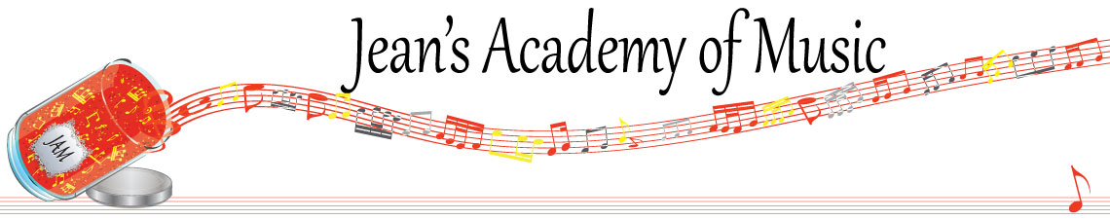
May 2023 “JAM” NEWSLETTER
IMPORTANT DATES TO MAKE NOTE OF:

April 30 Early Registration Deadline
May 22 Victoria Day NO LESSONS
May 23 - 25 Group Classes Details below
June 4 Year- end Recital
June 6 RCM registration deadline for August Exams
June 12 Final scheduled lesson day of the year
June 14 - 15 Make up Lesson Days
__________________________________________________________________________________________
Tuition
- Tuition for lessons is due at the 1st lesson of May either by CHEQUE, MASTERCARD, VISA, DEBIT, ETRANSFER, or CASH. Not all locations offer debit.
Please look after the tuition without requiring monthly invoices.
REMEMBER: a late payment fee has been introduced to overdue accounts on the 15th of the month.

NOTE: IN STUDIO/REMOTE LESSONS: please continue to observe (All Locations)
- Students are welcome in the studio and/or are eligible for home lessons if the student is well.
- Make ups are offered for lessons missed due to being sick.
- If the student is well enough to do a remote lesson in place of in person, we’re happy to accommodate that!
- All three of us teachers have various health issues that leave us vulnerable, so WE TRULY APPRECIATE THE RESPECT YOU ALL SHOW BY NOT COMING TO LESSONS SICK!!

Students of the Month: I am proud of how hard the students are working! Students of the month are: Hazel, Violet, Alyssa, Anja and Tobias! Congratulations to these students!

Stand out!

FALL REGISTRATION: please make your intentions known

NEWSFLASH!
1. Jenica & Jean are offering music camp at the Trafalgar location during the summer to promote retaining information learned over the course of the year.
WHEN: July 25 - 27
August 8 - 10
TIMES: 11:00 - 1:00 New Beginners up to 3rd year
2:00 - 4:00 Premier Level 3 and up
Activities will include: note reading, rhythm, music history, crafts, composition, ear training, sight reading, written work, etc.
REGISTRATION FEE: $30.00/week
CAMP FEE: $60.00/week
OPEN SPOTS: 8 each week

2. Theory classes will be available during the summer months to prepare for RCM theory exams. Please note the insert: Summer 2023 Theory
__________________________________________________________________________________________________
Here’s something to consider for your children
https://www.vancouversymphony.ca/series/kids-concerts/
________________________________________________________________________________________________
GROUP CLASSES MAY 23 - 25:

Tuesday May 23:
3:15 - 4:30 Madison, Grace, Simar, Samiya
4:30 - 6:00 Mason, Ethan, Ben, Sajan
6:30 - 8:00 Tobias and Isaac

Wednesday May 24:
3:15 - 5:15 Anja, Alex, Kai, Jonathan, Govind
5:15 - 7:15 Ameera, Violet, Lorelei, Alyssa

Thursday May 25:
3:15 - 5:15 Evan, Jacob, Atticus, Rory, Oliver
5:15 - 6:45 Hazel, Helena, Tuula, Vivienne

STUDENTS NOT IN GROUP: Lexi, Aleaya

