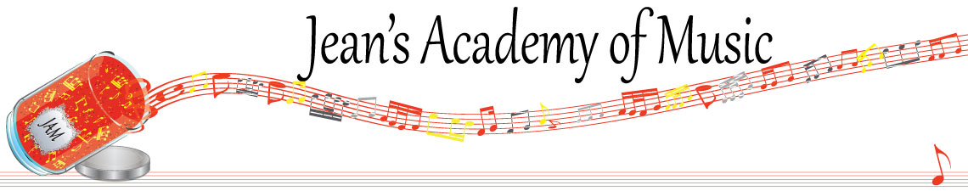
June 2023 “JAM” NEWSLETTER
IMPORTANT DATES TO MAKE NOTE OF:

June 12 Final scheduled lesson day of the year
June 13 onward as needed Make up Lesson Days
__________________________________________________________________________________________
Tuition: Tuition for lessons is due June 1st: either by CHEQUE, MASTERCARD, VISA, DEBIT, ETRANSFER, or CASH. Not all locations offer debit.
Please look after the tuition without requiring monthly invoices.
- NOTE: BECAUSE PAYMENT FOR LESSONS IS CALCULATED TO CREATE EQUAL PAYMENTS FOR THE 10 MONTHS OF THE TEACHING CALENDAR, YOUR JUNE TUITION IS THE SAME AS THE OTHER MONTHS EVEN THOUGH LESSONS ARE ENDING JUNE 12th. (you have received more lessons than you have paid for)

REMEMBER: a late payment fee has been introduced to overdue accounts on the 15th of the month.

If you are planning to continue lessons in the fall, please make it know because Teresa has limited availability and she is filling up quickly.
_____________________________________________________________________
REMINDER: make up lessons are only offered for sickness and family deaths. Birthday parties and other reasons for missing lessons don’t qualify for make ups. Thanks for your understanding. (Policy can be found at www.jeanacademy.com)
_____________________________________________________________________________
Student of the Month: congratulations to Harlow Beau!
_____________________________________________________________________

NOTE: IN STUDIO/REMOTE LESSONS: please continue to observe (All Locations)
- Students are welcome in the studio and/or are eligible for home lessons if the student is well.
- Make ups are offered for lessons missed due to being sick.
- If the student is well enough to do a remote lesson in place of in person, we’re happy to accommodate that!
- All three of us teachers have various health issues that leave us vulnerable.
WE TRULY APPRECIATE THE RESPECT YOU ALL SHOW BY NOT COMING TO LESSONS SICK!!

