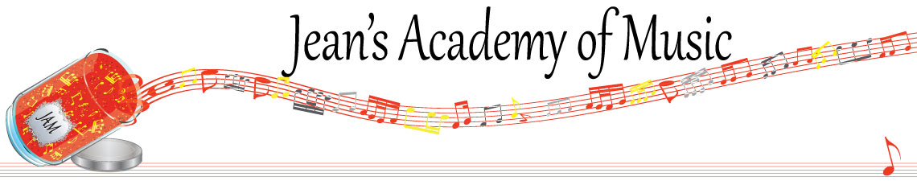
June 2023 “JAM” NEWSLETTER
IMPORTANT DATES TO MAKE NOTE OF:

June 4 Year- end Recital 3:30 Calvin Presbyterian Church
June 6 RCM registration deadline for August Exams
June 12 Final scheduled lesson day of the year
June 14 - 15 Make up Lesson Days (Trafalgar Studio)
__________________________________________________________________________________________
Tuition
- Tuition for lessons is due at the 1st lesson of June either by CHEQUE, MASTERCARD, VISA, DEBIT, ETRANSFER, or CASH. Not all locations offer debit.
- NOTE: BECAUSE PAYMENT FOR LESSONS IS CALCULATED TO CREATE EQUAL PAYMENTS FOR THE 10 MONTHS OF THE TEACHING CALENDAR, YOUR JUNE TUITION IS THE SAME AS THE OTHER MONTHS EVEN THOUGH LESSONS ARE ENDING JUNE 12th. (you have received more lessons than you have paid for)
Please look after the tuition without requiring monthly invoices.
REMEMBER: a late payment fee has been introduced to overdue accounts on the 15th of the month.

NOTE: IN STUDIO/REMOTE LESSONS: please continue to observe (All Locations)
- Students are welcome in the studio and/or are eligible for home lessons if the student is well.
- Make ups are offered for lessons missed due to being sick.
- If the student is well enough to do a remote lesson in place of in person, we’re happy to accommodate that!
- All three of us teachers have various health issues that leave us vulnerable, so WE TRULY APPRECIATE THE RESPECT YOU ALL SHOW BY NOT COMING TO LESSONS SICK!!

FALL REGISTRATION: please make your intentions known by returning your registration form with the fee or sending an email to state you’re not continuing with JAM.
_______________________________________________________________
SUMMER PIANO/GUITAR: available to begin right after your lessons end June 12th. Note that these extra lessons will be invoiced at the end of each month they’re taken. There is no registration fee for summer piano/guitar lessons.
_______________________________________________________________
Lessons at Wellesley Court Apartments: Please note that waiting between siblings in the lobby of the building isn’t permitted. Wait outside at the benches under the trees, sit in your car, or wait in the apartment quietly, please.
______________________________________________________
NEWSFLASH!
1. Jenica & Jean are offering music camp at the Trafalgar location during the summer to promote retaining information learned over the course of the year.
WHEN: July 25 - 27
August 8 - 10
TIMES: 11:00 - 1:00 New Beginners up to 3rd year
2:00 - 4:00 Premier Level 3 and up
Activities will include: note reading, rhythm, music history, crafts, composition, ear training, sight reading, written work, etc.
REGISTRATION FEE: $30.00/week
CAMP FEE: $60.00/week
OPEN SPOTS: 8 each week

2. Theory classes will be available during the summer months to prepare for RCM theory exams. Please: Summer 2023 Theory on the website.
__________________________________________________________________________________________________
Here’s something to consider for your children
https://www.vancouversymphony.ca/series/kids-concerts/
________________________________________________________________________________________________
ALL FORMS AND PIECES OF INFORMATION ARE ON THE WEBSITE: www.jeanacademy.com

