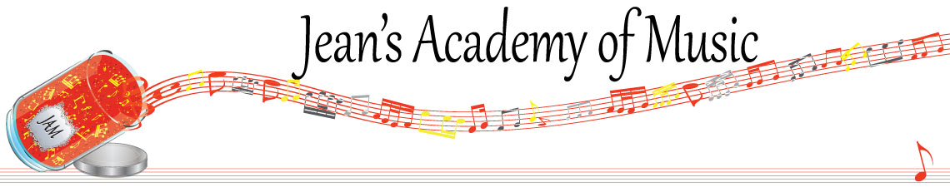
September 2023 “JAM” NEWSLETTER Alberta
IMPORTANT DATES TO MAKE NOTE OF:

September 18 Lessons Commence
October 9 Thanksgiving Day NO LESSONS
__________________________________________________________________________________________
Tuition:
- Tuition for lessons is due ON THE 1ST OF EACH MONTH IN ADVANCE unless other arrangements are made.
- NOTE: MASTERCARD, VISA, AND DEBIT ARE STILL AVAILABLE BUT WILL HAVE AN ADDITIONAL 3% ADDED TO THE PAYMENT.
- When setting up eTransfer, please make it repeating for the 1st of each month up to and including June. The tuition is divided up over the 10 months equally for ease of budgeting and simplicity. Send either to Teresa directly or jeanacademy@gmail.com
- Please look after the tuition without requiring monthly invoices.
- REMEMBER: a late payment fee has been introduced FOR PAYMENTS NOT RECEIVED BY the 15th of the month.

NOTE: IN STUDIO/REMOTE LESSONS: please continue to observe (All Locations)
- Students are welcome in the studio and/or are eligible for home lessons if the student is well.
- Make ups are offered for lessons missed due to being sick but please provide as much notice as possible. Just missing is a forfeit and not eligible for a makeup.
- Do not send coughing and or feverish children to lessons please.
- If the student is well enough to do a remote lesson in place of in person, we’re happy to accommodate that!
- All three of us teachers have various health issues that leave us vulnerable, so WE TRULY APPRECIATE THE RESPECT YOU ALL SHOW BY NOT COMING TO LESSONS SICK!!

ALL FORMS AND PIECES OF INFORMATION ARE ON THE WEBSITE: www.jeanacademy.com
JAM calendar Policy
Newsletters Registration forms

