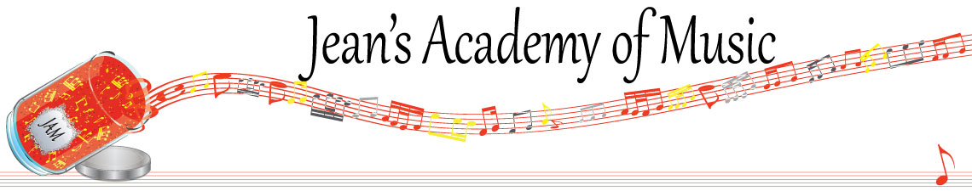
October 2023 “JAM” NEWSLETTER
IMPORTANT DATES TO MAKE NOTE OF:
October 9 Thanksgiving Day NO LESSONS
November 7 RCM exam application deadline for December & January in person exams
__________________________________________________________________________________________
Tuition:
- Tuition for lessons is due ON THE 1ST OF EACH MONTH IN ADVANCE unless other arrangements are made.
- NOTE: MASTERCARD, VISA, AND DEBIT ARE STILL AVAILABLE BUT WILL HAVE AN ADDITIONAL 3% ADDED TO THE PAYMENT.
- When setting up eTransfer, please make it repeating for the 1st of each month up to and including June. The tuition is divided up over the 10 months equally for ease of budgeting and simplicity. Send either to Teresa directly or jeanacademy@gmail.com
- Please look after the tuition without requiring monthly invoices.
- REMEMBER: a late payment fee has been introduced FOR PAYMENTS NOT RECEIVED BY the 15th of the month.

NOTE: IN STUDIO/REMOTE LESSONS: please continue to observe (All Locations)
- Students are welcome in the studio if well.
- Make ups are offered for lessons missed due to being sick but please provide as much notice as possible. Just missing is a forfeit and not eligible for a makeup.
- Do not send coughing and/ or feverish children to lessons please.
- If the student is well enough to do a remote lesson in place of in person, we’re happy to accommodate that!
- All three of us teachers have various health issues that leave us vulnerable, so WE TRULY APPRECIATE THE RESPECT YOU ALL SHOW BY NOT COMING TO LESSONS SICK!!

