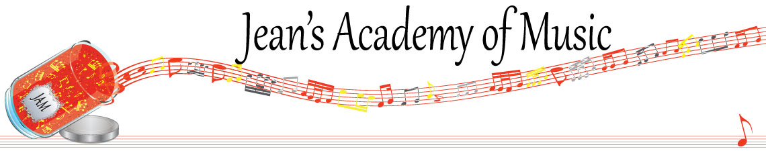
November 2023 “JAM” NEWSLETTER Alberta
IMPORTANT DATES TO MAKE NOTE OF:
November 7 RCM exam application deadline for December & January in person exams
November 13 Remembrance Day (in lieu day) NO LESSONS
_________________________________________________________________________________________
Tuition:
- Tuition for lessons is due ON THE 1ST OF EACH MONTH IN ADVANCE unless other arrangements are made.
- When setting up eTransfer, please make it repeating for the 1st of each month up to and including June. Please look after the tuition without requiring monthly invoices.
- REMEMBER: a late payment fee has been introduced FOR PAYMENTS NOT RECEIVED BY the 15th of the month.

NOTE: IN STUDIO/REMOTE LESSONS: please continue to observe (All Locations)
- Students are welcome in the studio if well.
- Make ups are offered for lessons missed due to being sick but please provide as much notice as possible. Just missing is a forfeit and not eligible for a makeup.
- Do not send coughing and/ or feverish children to lessons please.
- If the student is well enough to do a remote lesson in place of in person, we’re happy to accommodate that!
- All three of us teachers have various health issues that leave us vulnerable, so WE TRULY APPRECIATE THE RESPECT YOU ALL SHOW BY NOT COMING TO LESSONS SICK!!

