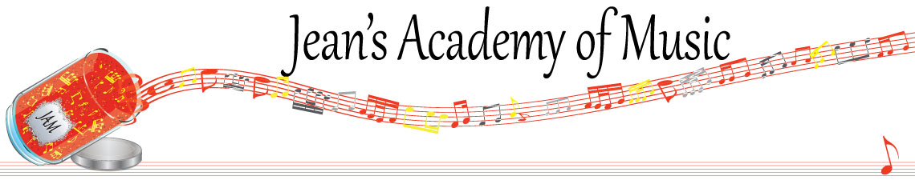
November 2023 “JAM” NEWSLETTER
IMPORTANT DATES TO MAKE NOTE OF:
November 7 RCM exam application deadline for December & January in person exams
November 13 Remembrance Day (in lieu day) NO LESSONS
November 14 - 16 Group Classes (details below)
November 20 Regular lessons
November 21 - 24 Semester Break NO LESSONS/MAKE UPS AVAILABLE
December 8 & 9 RCM Theory Exams
DECEMBER 10 CHRISTMAS RECITAL 3:00 P.M. CALVIN PRESBYTERIAN CHURCH
December 23 - January 7 Christmas Break NO LESSONS
_________________________________________________________________________________________
Tuition:
- Tuition for lessons is due ON THE 1ST OF EACH MONTH IN ADVANCE unless other arrangements are made.
- When setting up eTransfer, please make it repeating for the 1st of each month up to and including June. Please look after the tuition without requiring monthly invoices.
- REMEMBER: a late payment fee has been introduced FOR PAYMENTS NOT RECEIVED BY the 15th of the month.

NOTE: IN STUDIO/REMOTE LESSONS: please continue to observe (All Locations)
- Students are welcome in the studio if well.
- Make ups are offered for lessons missed due to being sick but please provide as much notice as possible. Just missing is a forfeit and not eligible for a makeup.
- Do not send coughing and/ or feverish children to lessons please.
- If the student is well enough to do a remote lesson in place of in person, we’re happy to accommodate that!
- All three of us teachers have various health issues that leave us vulnerable, so WE TRULY APPRECIATE THE RESPECT YOU ALL SHOW BY NOT COMING TO LESSONS SICK!!

Students of the Month: congratulations to Rebeca Osipov, Tuula, Evan, and Isaac who stood out in the studios in October! Well done!!

GROUP CLASSES: TECHNIQUE OLYMPICS

STUDENTS NOT IN GROUP: Lexi, Kaliyah, Inayat, Tobias, Isaac

Tuesday November 14:
3:15 - 5:00 Arya, Jaiden, Simar, Samiya, Madison, Mahi
5:00 - 6:30 Grace, Myra, Annelise, Rebeca

Wednesday November 15:
3:15 - 5:00 Sajan, Mason, Ethan, Ben
5:00 - 6:30 Helena, Hazel, Tuula, Vivienne, Evalie, Samantha, Amelia
6:30 - 7:45 Lorelei, Violet

Thursday November 16:
3:15 - 5:00 Evan, Jacob, Oliver, Atticus
5:00 - 7:00 Anja, Alex, Kai, Govind, Jonathan

All group classes are held at 42 - 3054 Trafalgar Street and replace the private piano lessons for that week. Masks are required for everyone.

ALL STUDENTS WILL BE REQUIRED TO PLAY FOR THEIR GROUP (NOT CHRISTMAS MUSIC AT THIS TIME) AND THEY WILL BE TESTED ON THEIR TECHNIQUE.

PLEASE HAVE STUDENTS BRING THEIR THEORY BOOKS TO LESSONS IF THEY HAVE THEM AT HOME.

PLEASE NOTIFY OF CONFLICTS AS SOON AS POSSIBLE.

