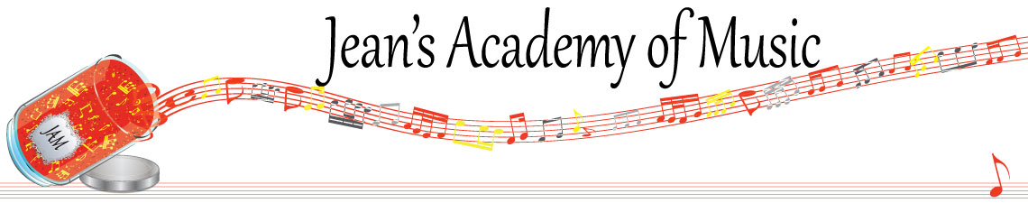
December 2023 “JAM” NEWSLETTER
IMPORTANT DATES TO MAKE NOTE OF:
December 8 & 9 RCM Theory Exams
DECEMBER 10 CHRISTMAS RECITAL 3:00 P.M. CALVIN PRESBYTERIAN CHURCH
(33911 Hazelwood Avenue)

December 23 - January 7 Christmas Break NO LESSONS
January 8 Lessons resume
February 19 Family Day NO LESSONS
_________________________________________________________________________________________
Tuition:
- Tuition for lessons is due ON THE 1ST OF EACH MONTH IN ADVANCE unless other arrangements are made.
- When setting up eTransfer, please make it repeating for the 1st of each month up to and including June. Please look after the tuition without requiring monthly invoices.
- REMEMBER: a late payment fee has been introduced FOR PAYMENTS NOT RECEIVED BY the 15th of the month.

NOTE: IN STUDIO/REMOTE LESSONS: please continue to observe (All Locations)
- Students are welcome in the studio if well.
- Make ups are offered for lessons missed due to being sick but please provide as much notice as possible. Just missing is a forfeit and not eligible for a makeup.
- Do not send coughing and/ or feverish children to lessons please.
- If the student is well enough to do a remote lesson in place of in person, we’re happy to accommodate that!
- All three of us teachers have various health issues that leave us vulnerable, so WE TRULY APPRECIATE THE RESPECT YOU ALL SHOW BY NOT COMING TO LESSONS SICK!!

Students of the Month: congratulations to Annelise, Evalie, Samiya, and Jonathan in November! Honourable mention goes to Grace and Kai. Well done!!

Wishing you all a blessed Christmas & a wonderful 2024!

