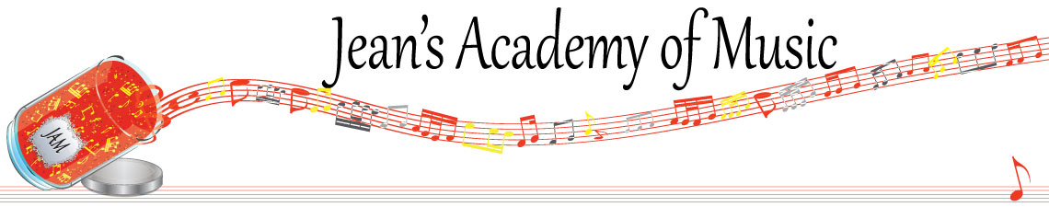
January 2024 “JAM” NEWSLETTER
IMPORTANT DATES TO MAKE NOTE OF:
January 8 Lessons resume
February 19 Family Day Check with Teresa re lessons

_________________________________________________________________________________________
Tuition:
- Tuition for lessons is due ON THE 1ST OF EACH MONTH IN ADVANCE unless other arrangements are made.
- When setting up eTransfer, please make it repeating for the 1st of each month up to and including June.
- Please look after the tuition without requiring monthly invoices.
- REMEMBER: a late payment fee has been introduced FOR PAYMENTS NOT RECEIVED BY the 15th of the month.

NOTE: IN STUDIO/REMOTE LESSONS: please continue to observe (All Locations)
- Students are welcome in the studio if well.
- Make ups are offered for lessons missed due to being sick but please provide as much notice as possible. Just missing is a forfeit and not eligible for a makeup.
- Do not send coughing and/ or feverish children to lessons please.
- All three of us teachers have various health issues that leave us vulnerable, so WE TRULY APPRECIATE THE RESPECT YOU ALL SHOW BY NOT COMING TO LESSONS SICK!

