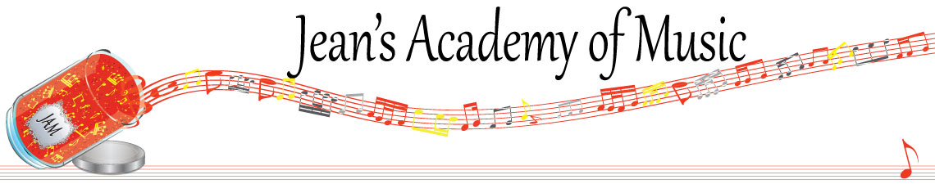
February 2024 “JAM” NEWSLETTER
IMPORTANT DATES TO MAKE NOTE OF:

February 19 Family Day NO LESSONS
February 20 - 22 Group Classes (details below) replace regular lessons for the week March 5 RCM exam application deadline for May and June in person exams
March 16 - 31 Spring Break NO LESSONS
June 9 Year End Recital SAVE THE DATE
_________________________________________________________________________________________
Tuition:
- Tuition for lessons is due ON THE 1ST OF EACH MONTH IN ADVANCE unless other arrangements are made.
- When setting up eTransfer, please make it repeating for the 1st of each month up to and including June. Please look after the tuition without requiring monthly invoices.
- REMEMBER: a late payment fee has been introduced FOR PAYMENTS NOT RECEIVED BY the 15th of the month.

NOTE: IN STUDIO/REMOTE LESSONS: please continue to observe (All Locations)
- Students are welcome in the studio if well.
- Make ups are offered for lessons missed due to being sick but please provide as much notice as possible. Just missing is a forfeit and not eligible for a makeup.
- Do not send coughing and/ or feverish children to lessons please.
- If the student is well enough to do a remote lesson in place of in person, we’re happy to accommodate that!
- All three of us teachers have various health issues that leave us vulnerable, so WE TRULY APPRECIATE THE RESPECT YOU ALL SHOW BY NOT COMING TO LESSONS SICK!!

MASKS: for lessons at the Trafalgar St. location. I do have “courtesy masks” at the front door, but please don’t rely on these for every lesson. I realize masks are not required at other places so forgetting happens…….
_______________________________________________________________
CHRISTMAS MUSIC: Christmas is over but some of you are still in possession of music that was lent to you. Please return at your next lesson so that you can borrow again next season.
_______________________________________________________________
ZOOM LESSONS: I am not familiar with all the audio settings in the zoom platform on laptops. Before your next zoom lesson, please look into making the settings so that original sound is enabled…..some computers have settings for musicians I believe. I use an iPad so the settings are different. If zoom isn’t working well due to audio issues perhaps consider downloading Skype. I find that is less complicated. *****if students are delayed in accepting their invitation to their lesson, that time is still considered part of their lesson. Our schedules don’t allow for delaying everyone after that late student. e.g. 4:00 - 4:30 in person is the same as 4:00 - 4:30 for a remote lesson. Parents, please help your child start on time.
_______________________________________________________________
Last year I included some guidelines and explanations for our counting methods that we employ. I recently completed a workshop with a clinician addressing the problem children have with counting with numbers and why that happens. Our children are dealing with finger numbers and numbers of lines and spaces etc., and when we throw counting with numbers into the mix many of them become lost. Some children can sort this out in their minds but others cannot. If we are using rhythm words in our counting with your children, please support us and don’t confuse them by using numbers. Trust me, down the road they will get to where you are in counting with numbers. We are benefiting from the research done in how to best work with their brain development.
_______________________________________________________________

Students of the Month: congratulations to Madison & Helena! Well done!!
_______________________________________________________________

Jenica/Joey and I want to make time for parents to come meet with us at the Trafalgar location to discuss the progress or concerns that might have arisen with piano lessons. In our busy lives we often don’t have that opportunity. We will make time available March 27 & 28. Please email me to make arrangements if this is something you’d like to access.

Group Classes February 20 - 22

STUDENTS NOT IN GROUP: Lexi, Kaliyah

If there is a conflict with the time please advise ASAP so that we can attempt to find an alternate class. Please note that classes are created in appropriate levels for the students so not every class is suitable to every student.

Tuesday February 20:
3:15 - 5:00 Arya, Jaiden, Simar, Samiya, Madison, Mahi, Mattias
5:00 - 6:30 Grace, Myra, Annelise, Rebeca

Wednesday February 21:
3:15 - 5:00 Sajan, Mason, Ethan, Ben
5:00 - 7:00 Helena, Hazel, Tuula, Evalie, Samantha, Amelia, Rachel

Thursday February 22:
3:15 - 5:15 Evan, Jacob, Oliver, Atticus, Lorelei, Eliana
5:15 - 7:15 Anja, Alex, Kai, Govind, Jonathan

Wednesday February 28
11:00 - 12:30 Tobias and Isaac regular lessons week of February 26 - 29 plus this
class there isn’t time for during group class week

All group classes are held at 42 - 3054 Trafalgar Street and replace the private piano lessons for that week. MASKS REQUIRED

All students will be required to play for their group, so please bring the music required. If the student is in possession of their theory books, please bring to the group class.

