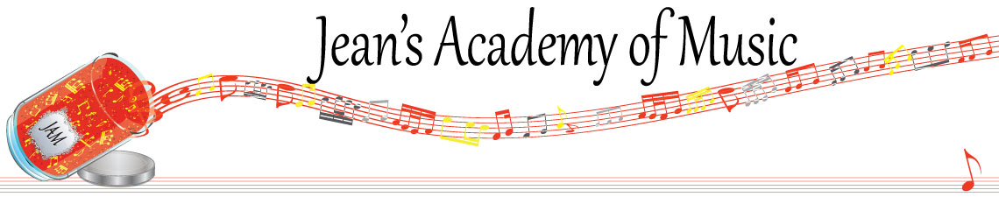
March 2024 “JAM” NEWSLETTER Alberta
IMPORTANT DATES TO MAKE NOTE OF:

March 5 RCM exam application deadline for May and June in person exams
March 24 - 31 Spring Break Check with Teresa re LESSONS
April 1 Easter Monday Check with Teresa re LESSONS
April 2 Lessons Resume
April 30 EARLY REGISTRATION DEADLINE
_________________________________________________________________________________________
Tuition:
- Tuition for lessons is due ON THE 1ST OF EACH MONTH IN ADVANCE unless other arrangements are made.
- Please look after the tuition without requiring monthly invoices.
- REMEMBER: a late payment fee has been introduced FOR PAYMENTS NOT RECEIVED BY the 15th of the month.

NOTE: IN STUDIO/REMOTE LESSONS: please continue to observe (All Locations)
- Students are welcome in the studio if well.
- Make ups are offered for lessons missed due to being sick but please provide as much notice as possible. Just missing is a forfeit and not eligible for a makeup.
- Do not send coughing and/ or feverish children to lessons please.
- If the student is well enough to do a remote lesson in place of in person, we’re happy to accommodate that!
- All three of us teachers have various health issues that leave us vulnerable, so WE TRULY APPRECIATE THE RESPECT YOU ALL SHOW BY NOT COMING TO LESSONS SICK!!

