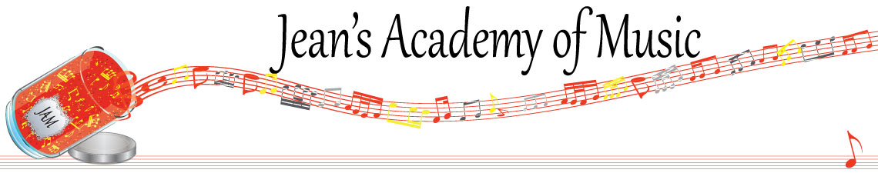
March 2024 “JAM” NEWSLETTER
IMPORTANT DATES TO MAKE NOTE OF:

March 5 RCM exam application deadline for May and June in person exams
March 16 - 31 Spring Break NO LESSONS
April 1 Easter Monday NO LESSONS
April 2 - 4 Group Classes Details below
April 30 EARLY REGISTRATION DEADLINE
June 9 Year End Recital SAVE THE DATE
_________________________________________________________________________________________
Tuition:
- Tuition for lessons is due ON THE 1ST OF EACH MONTH IN ADVANCE unless other arrangements are made.
- Please look after the tuition without requiring monthly invoices.
- REMEMBER: a late payment fee has been introduced FOR PAYMENTS NOT RECEIVED BY the 15th of the month.

NOTE: IN STUDIO/REMOTE LESSONS: please continue to observe (All Locations)
- Students are welcome in the studio if well.
- Make ups are offered for lessons missed due to being sick but please provide as much notice as possible. Just missing is a forfeit and not eligible for a makeup.
- Do not send coughing and/ or feverish children to lessons please.
- If the student is well enough to do a remote lesson in place of in person, we’re happy to accommodate that!
- All three of us teachers have various health issues that leave us vulnerable, so WE TRULY APPRECIATE THE RESPECT YOU ALL SHOW BY NOT COMING TO LESSONS SICK!!

MASKS: for lessons at the Trafalgar St. location. I do have “courtesy masks” at the front door, but please don’t rely on these for every lesson. I realize masks are not required at other places so forgetting happens…….
_______________________________________________________________
Students of the Month: congratulations to Tuula, Evan, Isaac, and Lexi with honorable mention going to Anja and Sajan! Well done!!
_______________________________________________________________

Jenica/Joey and I want to make time for parents to come meet with us at the Trafalgar location to discuss the progress or concerns that might have arisen with piano lessons. In our busy lives we often don’t have that opportunity. We will make time available March 27 & 28. Please email me to make arrangements if this is something you’d like to access.
_______________________________________________________________

Group Classes April 2 - 4

STUDENTS NOT IN GROUP: Lexi, Kaliyah

If there is a conflict with the time please advise ASAP so that we can attempt to find an alternate class. Please note that classes are created in appropriate levels for the students so not every class is suitable to every student.

Tuesday April 2:
3:15 - 5:00 Arya, Jaiden, Simar, Samiya, Madison, Mahi, Mattias
5:00 - 6:30 Grace, Myra, Annelise, Rebeca, Rachel

Wednesday April 3:
3:15 - 5:00 Sajan, Mason, Ethan, Ben
5:00 - 7:00 Helena, Hazel, Tuula, Evalie, Samantha, Amelia

Thursday April 4:
5:15 - 7:15 Anja, Alex, Kai, Govind, Jonathan

Date to be determined:
11:00 - 1:00 Tobias and Isaac
Date and time to be determined due to conflicts:
Evan, Jacob, Oliver, Atticus, Lorelei, Eliana

All group classes are held at 42 - 3054 Trafalgar Street and replace the private piano lessons for that week. MASKS REQUIRED

All students will be required to play for their group, so please bring the music required. If the student is in possession of their theory books, please bring to the group class.

