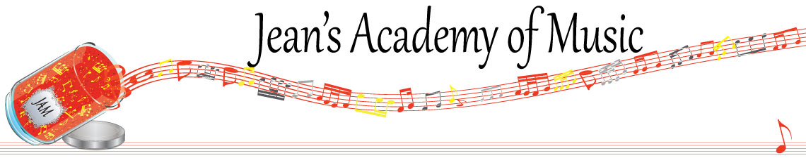
April 2024 “JAM” NEWSLETTER Alberta
IMPORTANT DATES TO MAKE NOTE OF:

April 2 Lessons Resume
April 30 EARLY REGISTRATION DEADLINE
May 20 Victoria Day No Lessons
_________________________________________________________________________________________
Tuition:
- Tuition for lessons is due ON THE 1ST OF EACH MONTH IN ADVANCE unless other arrangements are made.
- Please look after the tuition without requiring monthly invoices.
- REMEMBER: a late payment fee has been introduced FOR PAYMENTS NOT RECEIVED BY the 15th of the month.

NOTE: IN STUDIO/REMOTE LESSONS: please continue to observe (All Locations)
- Students are welcome in the studio if well.
- Make ups are offered for lessons missed due to being sick but please provide as much notice as possible. Just missing is a forfeit and not eligible for a makeup.
- Do not send coughing and/ or feverish children to lessons please.
- If the student is well enough to do a remote lesson in place of in person, we’re happy to accommodate that!
- All three of us teachers have various health issues that leave us vulnerable, so WE TRULY APPRECIATE THE RESPECT YOU ALL SHOW BY NOT COMING TO LESSONS SICK!!
Important things to note:
1. If a student is late joining an online lesson, the teacher is waiting a max of 10 minutes and then it is a forfeit
2. Teresa’s availability for the fall has changed dramatically and registration will be based on a first come first serve basis. Note the availability on the enclosed registration form.

