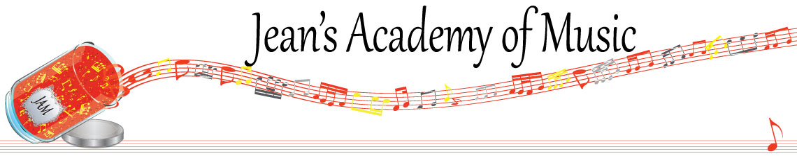
April 2024 “JAM” NEWSLETTER
IMPORTANT DATES TO MAKE NOTE OF:

April 30 EARLY REGISTRATION DEADLINE
May 20 Victoria Day NO LESSONS
May 21 - 23 Final Group Classes Details to come
June 9 Year End Recital SAVE THE DATE
_________________________________________________________________________________________
Tuition:
- Tuition for lessons is due ON THE 1ST OF EACH MONTH IN ADVANCE unless other arrangements are made.
- Please look after the tuition without requiring monthly invoices.
- REMEMBER: a late payment fee has been introduced FOR PAYMENTS NOT RECEIVED BY the 15th of the month.

NOTE: IN STUDIO/REMOTE LESSONS: please continue to observe (All Locations)
- Students are welcome in the studio if well.
- Make ups are offered for lessons missed due to being sick but please provide as much notice as possible. Just missing is a forfeit and not eligible for a makeup.
- Do not send coughing and/ or feverish children to lessons please.
- If the student is well enough to do a remote lesson in place of in person, we’re happy to accommodate that!
- All three of us teachers have various health issues that leave us vulnerable, so WE TRULY APPRECIATE THE RESPECT YOU ALL SHOW BY NOT COMING TO LESSONS SICK!!

MASKS: for lessons at the Trafalgar St. location. I do have “courtesy masks” at the front door, but please don’t rely on these for every lesson. I realize masks are not required at other places so forgetting happens…….
_______________________________________________________________
Students of the Month: congratulations to Grace, Oliver, Eliana, Tobias, and Arya! Well done!!
_______________________________________________________________
I am attaching the schedule for the students participating in the scholarship performance on April 30th as well as the program schedule for the second performance May 4th.
______________________________________________________________

I am also attaching the registration forms for Joey/Jenica and Jean. Your spots are held until April 30th and after that the waiting list individuals have access to any available times. If you know you’re returning, please get your information in quickly to keep your lesson time. As a courtesy, please let me know if you are discontinuing lessons with us so that we don’t bug you!
_______________________________________________________________

A summer theory schedule will be coming shortly!
______________________________________________________________

Parents please know that you are welcome to talk to us as teachers because we value your input. However, coming in to speak at the end of your child’s lesson is not appropriate whether there is a student after your child or not. We have our time spoken for just as you do. If you have a question or concern, please come in at the beginning of your child’s lesson time….the time you have purchased. Otherwise, contact us and arrange a mutually convenient time for us to talk or see each other. We appreciate your courtesy and respect!

